Little Lever Return to School Plan:

The school will return to normal working order in several phases which will mirror the government and local authority guidelines at each stage. The safety of students and staff is paramount. In order to ensure each return to school phase is safe and successful we will address the following factors at each phase:

- HEALTH AND SAFETY:
- National guidelines on Social distancing measures and how this is applied in school given the layout of the school building.
- Classroom audit… what is maximum number of people allowed in each room at any one time in order that social distancing is adhered to.
- Site Health and safety audit complete before any return to school
- Cleaning, hygiene and site preparation prior to return to school
- Protective equipment available for staff / students
- Cleaning and hygiene while on site
- Managing staffing and testing… who is available to work?
- Establishing the student / staff ratio that will enable social distancing measures to be achieved
- Staff and student movement around the school site.. entry and exit protocols
- Social time whilst on site (Break and lunch)
- Fire regulations/procedures
- First aid procedures
- Attendance and registers
- Staff and student wellbeing

- THE CURRICULUM and LEARNING:
- Establishing groups of students and Year groups that will take priority in returning to school
- Establishing a ‘new’ school day
- Establishing a new curriculum model and timetable for each year group – this may be full time or part time depending upon the Phase for each year group.
- Remote Learning – this may be full time or part time depending upon the Phase for each year group
- Behaviour, attitudes and consequences
- Personal development – Life Chances / student wellbeing
- The whole school priorities

- BUILDING CONFIDENCE AND RESILIENCE:
- Communicating clear plans and clear expectations with parents to build confidence and resilience
- Communicating clear plans and expectations with students and staff
- Monitoring and evaluating the delivery of each phase
- Ensure mechanisms are in place to respond quickly to change and adjust the next Phase of the plan accordingly

A return to school risk assessment has been completed to support this document. The risk assessment and Return to School Plan has been approved by the Trust after consultation with staff, parents/carers and union representatives.
Year 10 Phase 1 (15th June- 17th July 2020):
This initial Phase 1 attempts to map out a return to school plan with the current 2m Social Distancing guidelines in place based on the current Government guidance as of 3rd June.

In order to do this safely and effectively Phase 1 will only have Year 10 returning to school to support Remote Learning in English, maths and science.

Aims of Phase 1:
- To bring Year 10 back to school on a partial timetable each day to address misconceptions from remote learning in English, maths and science
- Ensure the Year 10 curriculum is robust and prepares students adequately for the rigour of GCSEs 2021
- To safely introduce social interaction whilst maintaining social distancing in order to raise morale and community spirit with Y10 students
- To increase confidence and resilience with students and parents before moving to Phase 2

Year 10 School Day Phase 1 – Supplementing Remote Learning and building confidence
Year 10 will be split into 4 cohorts of 52 students each. In Year 10 Phase 1, students will only come into school to study English, maths and science. In line with the current government guidance each cohort will only come into school on 1 day each week for a face to face session in English, maths and science. Each English, maths and science session will last 1 hour 15 minutes.

Year 10 Timetable Phase 1:

 | Mon PASTEUR | Tues SNOW | Weds  FLEMING | Thurs  JENNER | FEEDBACK FRIDAY
Arrive  8.45am |  |  |  |  | Opportunity for students to ask questions about their work in any subject with their teacher live.
Session 1  9am - 10.15am | English | English | English | English
Transition Break
10.15am -10.30am
Session 2 – 10.30- 11.45am | Maths | Maths | Maths | Maths
Transition BREAK
11.45 – 12.00pm
Session 3 12.00 – 1.15pm | Science | Science | Science | Science | Catch up time students have the opportunity to catch up on any tasks they have not yet completed from the week
Depart
1.15pm

Why have we had to modify the original plan?

Unfortunately, government guidance issued to secondary schools has been modified several times and was changed after our original plan had been finalised. The current government guidance states:

Secondary schools should therefore ensure that only a quarter of pupils in year 10 and year 12 are in school at any one time, including vulnerable children and children of critical workers in those year groups who are still encouraged to attend full-time. This meant that our original plan of bringing in a quarter of the year at different times on the same day was not possible.

All schools are different, and it is not possible for government to set specific national guidelines that could be universally applicable.

…mixing between different groups of pupils should be kept to a minimum. We recognise that the range of subjects taught in secondary schools means that some mixing may be unavoidable to provide pupils with face-to-face support from subject teachers. We would expect that these groups are still smaller than normal. We would also expect schools to minimise mixing for arrival, lunchtime, breaks and departure. While in general groups should be kept apart, brief, transitory contact, such as passing in a corridor, is low risk
…ensuring sufficient distance between pupils is likely to mean classes are no more than half their usual size. However, this may vary due to individual school circumstances (for example a larger group could be taught in a larger space provided social distancing can be maintained and mixing is minimised).

Each cohort is named after a famous scientist /epidemiologist who transformed the medical profession and saved millions of lives with their medical work and vaccines. The reason for doing this is to develop confidence and hope in our students that there is a solution and this will not last forever!

Monsieur Louis Pasteur was a 19th century French scientist, commonly known as the father of microbiology. Pasteur discovered that microorganisms caused fermentation and disease and his discoveries provided direct support for the germ theory of disease. He also developed the technique of pasteurisation, which we use today to preserve food products such as milk.

Sir Alexander Fleming was a Scottish scientist/bacteriologist, who discovered penicillin, the first ever antibiotic which was being produced by a mould growing in one of his petri dishes. He won the Nobel Prize in Physiology or Medicine in 1945 and has contributed to the saving of millions of lives all around the world, thanks to the development of antibiotics.

John Snow was an English Scientist, responsible for the discovery of Cholera as a water-borne disease. During the 1854 outbreak, in Soho London, Snow mapped the cases against a street map and traced the problem back to a contaminated water well. He is widely considered to be the founder of epidemiology- the branch of medicine which deals with the study of and analysis of disease within a population.

Edward Jenner was an English surgeon, who discovered the vaccination for smallpox. Jenner realised that anyone who had contracted cowpox, would not later contract smallpox. Upon testing his theory, Jenner discovered inoculation, eliminating smallpox and contributing to the saving of millions of lives with the modern day vaccination.
New Remote Learning Timetable
As a result of this the remote learning timetable for Year 10 will change to reflect the time students have in school.

Those students who are not in school receiving their face to face session in English maths and science will attend one of their Option Subject sessions remotely. Remote Option Subject sessions will always take place in the morning. These are opportunities for students to receive Live feedback and support from their Teacher. Remote Learning for English, maths and science will take place in the afternoon. The timetable below sets out how this will work.

Time | Cohort | MONDAY | TUESDAY | WEDNESDAY | THURSDAY | Feedback FRIDAY
9am – 12pm | PASTEUR | IN SCHOOL | Option A | Option B | Option C | All Subjects (Live)
 | SNOW | Option C | IN SCHOOL | Option B | Option A
 | FLEMING | Option C | Option A | IN SCHOOL | Option B
 | JENNER | Option C | Option A | Option B | IN SCHOOL
1.15 – 3.30pm | PASTEUR | English | Maths | Science | Catch Up Core  English Maths Science | Catch up Friday
 | SNOW
 | FLEMING
 | JENNER

ALL Option subject sessions will operate from 9am – 12pm. All students in each cohort who are not in school on that day can log into their session between 9am and 12pm for their Option subject to receive live feedback, support and guidance from the teacher at that time. Students do not have to log in at these times as long as they complete all the tasks set to the best of their ability before 5pm on Sunday evening. It is simply an opportunity for students to receive additional Live feedback and support if they need it.

Each afternoon from 1.15pm to 3.30pm students will have the opportunity to receive live feedback, support and guidance from English, maths and science teachers in line with the timetable above. Students do not have to log in at these times in English, maths and science as long as they complete all the tasks set to the best of their ability before 5pm on Sunday evening. It is simply an opportunity for students to receive additional Live feedback and support if they need it.

Catch Up Core – this is an opportunity for any student to receive live feedback, support and guidance from teachers in English, maths and science

All Remote Learning and feedback sessions will be conducted through Google Classroom either directly via messaging or face to face via Google Meet. To ensure security no other platforms will be used to conduct face to face sessions other than Google Meet.

There will be a series of tasks to complete in the week for every subject. This will be checked by teachers throughout the week with a final check at 5pm each Sunday to ensure tasks have been completed. This should give students enough time to catch up on Friday and over the weekend should they need to.

The current Remote Learning Planner will be set each week and will be available to view on the website. This will explain the tasks students need to complete and will provide a link to Google Classroom with the classcode.

We are also introducing ‘Feedback and Catch up Fridays’

Feedback Friday’s will operate from 9am -12pm. It is an opportunity for students to ask questions via Google Classroom to their teachers in option subjects in Year 10 (and English, maths and science in Y7 to Y9). Teachers will be available live and will respond either via messaging on Google Classroom or will invite students to a face to face session via Google Meet if it needs a more detailed explanation.

Catch up Friday will operate from 12pm – 3pm. We have also removed the Boost session for students. Taking into account feedback from staff and parents we have introduced a ‘Catch up Friday’ session which will allow students time to complete the remote learning tasks that have been set in English, maths, science and their Option subjects.

How much lesson time will each subject get per week?

Subject | Eng | Ma | Sci | Opt A | Opt B | Opt C
Lessons Face to Face  (1hr 15mins) | 75 | 75 | 75 | 0 | 0 | 0
Remote Learning Time in mins (2hr 30mins) | 150 | 150 | 150 | 120 | 120 | 120
Total Time in mins | 225 | 225 | 225 | 120 | 120 | 120
Normal curriculum time in mins | 250 | 250 | 300 | 150 | 150 | 150

Which cohort and class is my child in?

In each subject each cohort will be split into different classes which will cater for the range of abilities in each cohort. Students may be in different classes in English, maths and science to support their learning and progress. We want to keep the number of other students they come into contact with as low as possible and as a result we have modelled the number of students each student would come into contact with outside of their English class. On average students will be in contact with 13 more students outside of the students in their English class. This means on average they will come into contact with 23 students in their cohort.

Middle Leaders of English, maths and science have strategically staffed their classes so it provides capacity for the team to still maintain remote learning for Year 10 and all other year groups.

Please view the Return to School webpage to find out which cohort students are in:
https://www.little-lever.bolton.sch.uk/return/

Arrival and Departure from School:

Arrival: Students will enter the building via the staff car park from 8.45am if they are arriving by car. Students who walk to school will arrive via the main student entrance to school.
Students will line up at the front of school in the designated areas for their English class. Their teacher will be there to greet them and this will be clearly labelled for students.

Protocols for Front of School:
- Parents will drop off students in the drop off zone of the car park at 8.45am. Parents will not be allowed to leave their car. Staff must park their cars at the far end of the car park before 8.30am
- Students will line up 2m apart as indicated by markings on the floor in their classes for English
- Class teachers will be there to greet students as they arrive and instruct them to line up 2m apart whilst also keeping a 2m distance from the students
- Classes will then be escorted in to the school one class at a time (largest class first). As the class enters the building they will have their temperature checked by a member of SLT and will wash their hands with the hand sanitiser.
- The teacher will then escort students to their classroom along the designated one way route
- SLT will then signal for the next class to enter the building and the process will be repeated until all classes have safely entered the building
- Students will receive the same amount of allocated time each day so the last class to enter will be the last class to leave so they have same curriculum time.
- The gates at the front of school will be locked once all students have entered the building.
- Any students arriving late will have to buzz the intercom. A member of staff will meet them at the door maintaining a distance of 2m. Their temperature will be checked and they will wash their hands using the hand sanitiser before entering the building. They will then be escorted to their classroom.
- If students have a temperature they will not be allowed into the building and will be sent home immediately after contacting parents / carers.

Markers will be painted onto the floor at the front of school in the following way to clearly indicate to students where to stand.

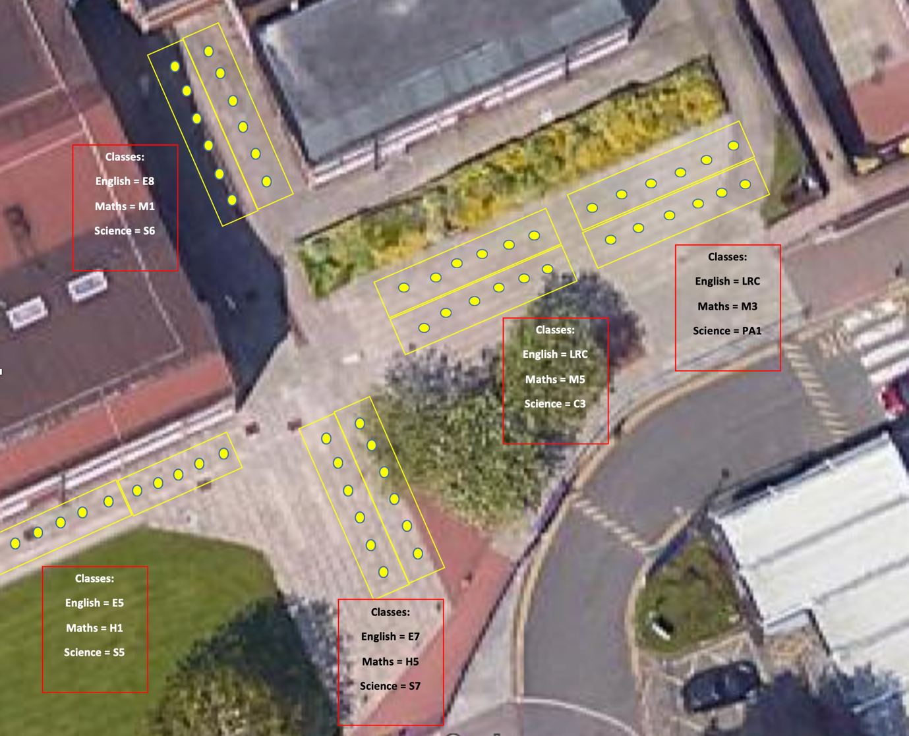

Departure:
- Each cohort will leave following the exit which will be clearly identified.
- Each class will be dismissed by a member of SLT so this is staggered and will be based on the last in last out scenario from the arrival procedures.
- Students will place all their equipment in a A3 zip wallet and seal it.
- Students will then stand behind their desk.
- The member of SLT will lead students out of the classroom and with the teacher will ensure each student washes their hands using the hand sanitiser on the way out. Students will follow the member of SLT whilst maintaining social distancing measures.
- The teacher will be the last person out of the classroom and will also escort students out of the building ensuring they maintain 2m apart as they do so.
- Again, every student will wash their hands with the hand sanitisers when leaving the building. Students will maintain social distancing guidelines as they leave and will be encouraged to do this until they arrive home.

Protocols for transition breaks between lessons:
- Each class will be dismissed by a member of SLT so this is staggered and will be based on the last in last out scenario from the arrival procedures.
- Students will place all their equipment in a A3 zip wallet and seal it.
- Students will then stand behind their desk.
- The member of SLT will lead students out of the classroom and with the teacher will ensure each student washes their hands using the hand sanitiser on the way out. Students will follow the member of SLT whilst maintaining social distancing measures.
- The teacher will be the last person out of the classroom and will also escort students out of the building ensuring they maintain 2m apart as they do so.
- Again, every student will wash their hands with the hand sanitisers when leaving the building. Students will maintain social distancing guidelines as they leave.
- Students will be escorted to the Front of the School.
- Students will line up 2m apart as indicated by markings on the floor in their classes for their next lesson (as they did when they arrived in the morning)
- Class teachers will be there to greet students as they arrive and instruct them to line up 2m apart whilst also keeping a 2m distance from the students
- Classes will then be escorted in to the school one class at a time (largest class first).
- The teacher will then escort students to their classroom along the designated one way route
- Before students enter the classroom they will wash their hands using the hand sanitisers which will be attached to the wall of each classroom.
- SLT will then signal for the next class to enter the building and the process will be repeated until all classes have safely entered the building

Transport Arrangements:
Following the government guidelines we strongly encourage students not to use public transport when travelling to and from school. Where possible students should walk or cycle. If students do need to use public transport they must follow the government guidance on wearing a face covering. Please click the link below for the official guidance on this. https://www.gov.uk/guidance/coronavirus-covid-19-safer-travel-guidance-for-passengers

Special provision will be made for students to lock their bike to the school fence on the staff car park. Students will need to provide their own bike lock in order to do this.
Staff will need to park their cars at the far end of the staff car park near T6

The school bus service will be running each day and will follow its normal route in order to that students arrive at 8.45am. This is not a public bus and is only available to students at Little Lever school. Students must wear their uniform in order that they are easily identifiable as a Little Lever student.
The bus company will be following strict social distancing guidelines to ensure students who may wish to use the school bus are not closer than 2m from each other at any time. Once the bus has arrived on the school site students will remain on the bus until a member of SLT escorts them off the bus to line up in their English classes at the front of the school.
Staff and Student movement around the site:

- Once students are in their classroom they must not leave that area for any reason unless there is a medical condition or they need to use toilet.

- Toilets will be available for each Zone:
- English = Mrs Pearson’s office/toilet
- Maths and Science = Girls and boys toilets by canteen

- There will be a one way system in place to move around the building.
- There will be arrows on the floor which will be 2 meters apart to indicate which direction to move around the building and how far away you must stay from the person in front or behind you (see pictures below)

Everyone must adhere to the one way system. Students who are being escorted to lessons by staff will be exempt from following the one way system to ensure they go directly to their classroom by the shortest and safest distance.

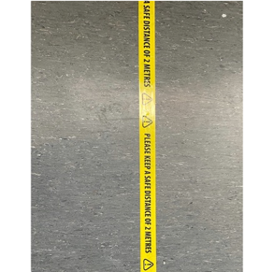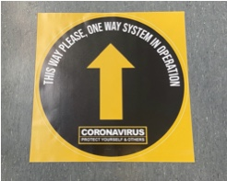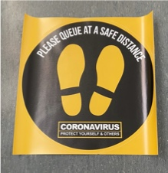

Classroom layout:

- Chairs will be removed from classrooms to indicate the maximum number of people allowed in the classroom to maintain social distancing guidelines
- A number will be clearly displayed outside each classroom to indicate the maximum number of people allowed in each room.
- Chairs will be placed in specific areas of each classroom and must not be moved.
- The position of the chair will be indicated by a sticker on the floor.
- Classrooms will be set out to appropriately fit a safe number of students in them.
- Classrooms must not be re-arranged without permission from the site manager and Principal.
- Hand sanitisers will be placed at strategic points along corridors and in every classroom being used so staff and students can regularly wash their hands on entry and exit to every classroom they visit

Expectations in classrooms:

- Students and staff will use hand sanitisers on entry and exit to the classroom.
- Teachers will teach in the same classroom for the day.
- All classrooms will have socially distant fixed seating which should not be moved. Students should sit in the same seat at all times and must not move without permission from the teacher.
- Teachers will keep a seating plan and a copy of this will be kept centrally
- Desks and chairs should not be moved
- Teachers should avoid movement in the classroom
- Windows should be left open during the lessons unless it disrupts learning
- Group activities and any close contact between individuals should be avoided
- We will provide equipment for all students in an A3 zip wallet.
- Students must not bring any equipment into school including a bag
- Equipment must not be shared under any circumstances.
- We will provide students with a bottle of water in their maths and science lesson. These will be placed on students’ desk. Students must leave the bottle of water on their desk when they leave as cleaners will dispose of this when they clean the room.
- We will provide an optional snack for students in their maths lesson. This will be a waffle/biscuit in a sealed wrapper. These will be placed on students’ desks. Again, students must leave the wrapper on the desk at the end of the session and cleaners will dispose of this in line with government guidelines.

Student expectations:

- Students are expected to wear school uniform in line with the uniform policy. We will take a flexible approach to school blazers i.e. they do not have to be worn.
- Piercings will not be allowed and students should remove all piercings before they come to school.
- Students should not leave the classroom until the lesson has finished
- Students with medical conditions who need to leave the classroom will be allowed to do so at the discretion of the teacher. Students who leave the lesson for medical reasons should be issued a pass and move straight to main reception and await further instructions.
- Students who need to leave the lesson to use the toilet will be issued a pass at the discretion and professional judgement of the teacher. Students will be escorted by a member of the SLT to the toilet. Every time a toilet is used it will be cleaned by our contracted cleaners
- Students should avoid all physical contact in school and on the way to school… No hugs, shaking hands etc…
- When in the classroom students should sit in the same place at all times and not move from this place unless instructed to do so by the teacher.
- Students must maintain a safe distance from others between and during their lesson
- Students should not share belongings with each other (stationery, food etc…)
- Students follow the same behaviour expectations and the same behaviour protocols will be in place. There will be no consequence room. Instead students will be placed immediately in isolation or will be sent home. This will be at the discretion of the senior leader /principal in school at the time
- Students that are non-compliant or pose a health and safety risk will be sent home immediately. This will be at the discretion of the Principal.

Actions if a student or member of staff shows symptoms of COVID-19

Actions if a student shows COVID-19 symptoms:

- Isolate in school in the conservatory
- Inform parents
- Send student home and advise they self isolate for 7 days and the household self isolates for 14 days
- Encourage student to get tested
- If test is negative – return to school and household ends self isolation
- If test is positive moved to confirmed case scenario

Actions if a member of staff shows COVID-19 symptoms:

- Send home immediately
- Inform HR before leave the site
- Advise they self isolate for 7 days and the household self isolates for 14 days
- Organise a test for the member of staff with their permission
- If test is negative – return to school and household ends self isolation
- If test is positive moved to confirmed case scenario

In line with government guidance staff and students in all settings will be eligible for testing if they become ill with coronavirus symptoms as will members of their household.

Actions if there is a confirmed case of COVID-19 in the school

- Student or staff member tests positive for COVID-19
- Individual receives medical advice and/or treatment
- Class or group teacher/student was in contact with sent home and told to self isolate for 14 days.
- Contact Public Health England (PHE) who will investigate and advise
- If further cases are detected within the school again contact PHE who will investigate and advise.

PPE Equipment:
We will follow the official government guidance below:
Official Government guidance on PPE:

Personal protective equipment (PPE) including face coverings and face masks
Wearing a face covering or face mask in schools or other education settings is not recommended. Face coverings may be beneficial for short periods indoors where there is a risk of close social contact with people you do not usually meet and where social distancing and other measures cannot be maintained, for example on public transport or in some shops. This does not apply to schools or other education settings. Schools and other education or childcare settings should therefore not require staff, children and learners to wear face coverings. Changing habits, cleaning and hygiene are effective measures in controlling the spread of the virus.
Student Induction Process:
Before students return to school an induction process for each cohort would take place. The induction process will take place in the morning of each cohort’s day in school during the week beginning 22nd June. This would give us the opportunity to explain in detail the plans moving forward and the expectations of working safely in this way.

Video guidance will be posted on the school website to support students and parents on Arrival procedures in preparation for students’ first day.

Student Induction: Week beginning 22nd June
Induction will take place in the students’ first English lesson. This will be video guidance from Mr Mckeon (Principal). This video guidance will cover the following topics:

- Welcome back… happy to see you!
- Support available to you – bereavement, mental health support etc…
- Social Distancing guidelines
- Arrival and Departure procedures
- Student expectations
- How we will support you with Remote Learning
- Equipment
- Praise Culture

PASTEUR – Monday 22nd June 9.00am – 9.15am

SNOW – Tuesday 23rd June 9.00am – 9.15am

FLEMING – Wednesday 24th June 9.00am – 9.15am

JENNER – Wednesday 25th June 9.00am – 9.15am

Students will follow the arrival to school procedures detailed in this document. They will line up in their English classes on the yellow dots at the front of school.
Key Worker and Vulnerable Students:

Provision will still be made for key worker students and vulnerable students each day.

These students will be based in the I block (MfL block). Some year 10 students may follow this plan. Year 10 Key Worker and vulnerable students will be able to attend their planned English, maths and science sessions on the day their cohort is in school. They will return to the I block from 1.15pm after these sessions have finished.

Key worker and vulnerable children will follow the current provision put in place for them i.e. the current ‘Daily Plan’ document. Their day will start at 8.30am and will finish at 3.05pm

Break times and lunch times will be adapted so as not to clash with arrival, transition breaks and departure times of Year 10.

Lunch and Break Times:

LUNCH TIMES for YEAR 10:

Following this model it is proposed that students will not have lunch in school. For Year 10 students parents and carers will be expected to provide lunch when they get home after finishing at 1.15pm

BREAK TIME for YEAR 10:

Following this model it is proposed that students will have a Transitional break after each session. This will not be social time but an opportunity for students to break from learning , get some fresh air and then get ready for their next session.

All litter must be disposed of properly. No litter should be left on the floor. It must be placed in a bin which will be by the door when students enter or exit the classroom. Bins will be sealed at the end of the day by cleaners and disposed of in line with government guidance. No hot food will be provided by the school.

ATTENDANCE Procedures:

We wanted to be clear that there is no directive for your children to attend school. The government strongly advises that parents and carers send their children into school but this is a decision that lies with the parent or carer. No fines will be issued for non-attendance and ultimately it is the parents’/carers’ decision whether or not to send their child/children into school.

Reporting Your Child Absent during the Covid-19 Period.
It is important that you inform the school if your child is going to be absent, for whatever reason, as soon as possible i.e. by 8.30am.
You may do this in the following ways:
- By telephoning the school office 01204 333300
- By sending a text message 07592 328139
- By sending an email to Attendance-Staff@little-lever.bolton.sch.uk

Please ensure that you state clearly one of the following reasons for absence:
- Will NOT be attending – parental choice
- Ill with CONFIRMED Covid-19
- Self-Isolating with Covid symptoms (7 days)
- Self-Isolating due to household/contact having Covid or symptoms of Covid (14 days)
- Shielding
- Ill – for any other reason other than COVID-19

It remains the responsibility of the parent/carer to inform the school of student absence.
If a student is expected to be in school, and no notification of absence has been received, the Attendance and Welfare Leader will endeavour to contact parents/carers by telephone.
If a pupil who is subject to a Child Protection Order is absent without satisfactory explanation the Early Intervention Team will be contacted before 10.00am and asked to undertake a home visit.
Where there is a safeguarding concern relating to a student’s absence, and the student is not subject to a Child Protection Order, the schools Designated Safeguarding Lead will be informed and a home visit may be undertaken as a matter of urgency. The purpose of this visit is to establish the safety and well-being of the student.

Fire Procedures:

In line with government guidance should there be a fire alarm student will follow the normal fire alarm procedures. In this scenario students will not be expected to socially distance, as per the government guidance there would potentially be an immediate risk of harm and therefore the priority would be to remove staff and students from the building as quickly and as safely as possible.
Students would line up in silence in single file on the back yard in their English, maths or science classes. A register would be taken by the teacher of the class and we would follow our normal procedures.
This will be part of the induction programme for students and staff.

First Aid:

There will always be a first aider on the school site.

If a student or adult needs first aid the first aider must administer this if it cannot be done by the student or adult. In order to do this staff can wear a pair of latex gloves. Once used these items must be disposed of securely in a bin liner tied at the top. This must then be placed in a second bin liner which will again be tied at the top and clearly labelled for the cleaning staff to dispose of appropriately.

