01 November 2021
The Bronze Duke of Edinburgh’s Award
Dear Parent/Carer,
As part of the school’s commitment to enriching the curriculum of our students your child is being offered the opportunity to undertake the Duke of Edinburgh’s Award at Bronze level.
Colleges, universities and employers look for what young people have done as well as their studies in order to judge their character. This includes traits such as teamwork, commitment and resilience; all of which the challenges of the Award can provide. It will not only give them examples to talk about in their future applications for college and university places, jobs and apprenticeships but opportunities to make friends and have experiences which they will remember for a long time.
However, the offer of this place is dependent on their commitment. They firstly need to find opportunities to complete their skill, volunteering and physical activities. These can be interests they have both in and out of school which they can provide evidence of participation in on a regular basis for 3-6 months and hope students will use enrichment opportunities to fulfil these. The enclosed booklet contains lists of activities to give them some ideas as well as recording sheets which they can use to record the dates and types of activities. They should also record photos and videos which they will be able to upload to the eDofE database later in the year. Activities undertaken consistently (e.g. once per week) since October 2021 will count.
The expedition element of the programme is often the most challenging. This will involve young people training for and completing a two-day qualifying expedition where they are self-sufficient and travel under their own navigation. The training will include theory sessions and practice expeditions, and the schedule for these is listed below:
Parent’s Information Evening – Wednesday 24th February 2022 – 5pm – Drama Centre
Practice Walk – Sunday 13th March 2022 – Rivington (parents to drop off and collect)
Practice expedition – 8am Saturday 23rd April – 4pm Sunday 24th April 2022 – Waddow Guiding Camp, Lancashire
Qualifying expedition – 8am Saturday 18th June – 4pm Sunday 19th June 2022 – Llandegla, North Wales

We hope you will assist and encourage your child to take the part in the programme and help them face up to some challenges while having fun. We want the whole programme to reflect our Growth Mindset approach where our young people see positive opportunities and not focus on what they cannot do… yet.
We will hold a parent’s information evening in the spring regarding the expeditions. For now, please complete the permission slip and table below so that we can support your child towards gaining the Award. If you have any questions, feel free to get in touch using the email address below.
Yours faithfully
Mr M. Foulkes
Duke of Edinburgh’s Award Manager
mfo@little-lever.bolton.sch.uk

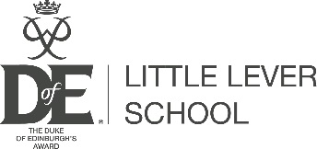
Student Name: __________________________ Form: ___________

I give permission for my child to participate in the Duke of Edinburgh’s Award programme on each of the three dates listed above.

Signed: _______________________________ Relationship: _____________ Date: __________

Please indicate below the activities your child intends to complete and the timescales (2 for 3 months and 1 for 6 months)

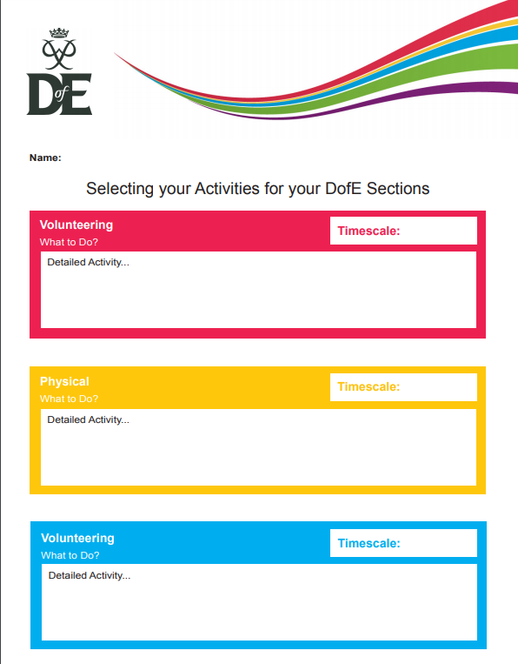
Skills
Please hand directly to Mr. Foulkes in H2 or Mrs. Craven in S8 by the end of the week.

