Joe Smith 11V
This is your child’s academic report which provides you with the following information:
- Predicted Grades made by each subject teacher of the GCSE 9-1 grade they believe your child is capable of achieving at the end of Year 11,
- Target Grades,
- ‘Work Hard’ scores for each subject your child studies,
- Retrieval Practice completion records,
- Your child’s attendance record for this term.

- Predicted Grades
Each Predicted Grade is based on a variety of information; step assessment marks, low stakes quiz outcomes, evidence of work produced in class and remotely, in addition to mock exam results and completed coursework tasks for those students in Years 9, 10 and 11. Please note that predictions in all years can vary throughout the year, as the national picture of GCSE performance and exam board grade boundaries change.

- Target Grades
You will be able to ascertain how your child is performing in comparison to how students perform nationally with the same Key Stage 2 records by comparing their Predicted Grade with their two Target Grades.

If your child’s Predicted Grade for a subject is in line with their top 20% target grade, it means your child is performing in the top 20% nationally in their subject and is making excellent progress with their learning.
If your child’s Predicted Grade for a subject is in line with their top 50% target grade, it means your child is performing in the top 50% nationally in their subject and is making expected progress with their learning.
If your child’s Predicted Grade lies below the 50% grade, your child is performing in the bottom 50% nationally in the subject and their progress with their learning is limited. This would be an area of focus in terms of home study and revision.

9-1 GCSE Grades Explained
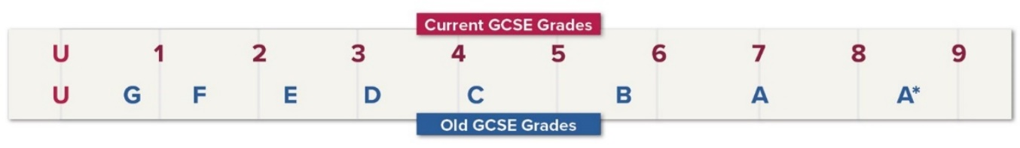
The highest grade is 9, while 1 is the lowest, not including a U (ungraded). Three number grades - 9, 8 and 7 - correspond to the two previous top grades of A* and A. Grade 4 is the Standard Pass grade. If students don’t achieve a Grade 4 in Maths and English, they’ll need to continue studying these subjects, post-16. Grade 5 is the Strong Pass, which colleges and further eduction providers set as entry requirements.

Joe Smith 11V
- ‘Work Hard’ Score Criteria
These scores represent your child’s effort in the classroom and their attitudes to their learning. Every two weeks students are awarded a ‘Work Hard’ score of 1 – 4 by each of their teachers which generate the Praise List. This report provides you with an overall ‘Work Hard’ score based on how they have performed in each subject across the whole term.
1 | We couldn’t ask any more of your child. Their classwork and retrieval practice are always completed to the best of their ability. No Corrections issued.
2 | Whilst there is a little room for improvement, your child will make good progress if they continue to work hard and complete their retrieval practice in this way. No Corrections issued.
3 | There are concerns with how hard your child is working. A Correction may have been issued. There has been at least one instance where retrieval practice has not been completed.
4 | There are serious concerns about how hard your child is working which means they will be making limited progress. Multiple Corrections have been issued. Retrieval Practice is not being completed.

- Retrieval Practice
Retrieval Practice (homework) is set for every subject each fortnight across our two-week timetable. The Retrieval Practice Completion column shows how many Retrieval Practices have NOT been completed across this term. If a score of zero (0) is recorded, that means EVERY Retrieval Practice has been completed successfully and NONE have been missed in that subject. Your SIMS Parent app has records of what retrieval practice has been set and your child should also be recording them in their school planners.

- Attendance
The school places great importance on attendance. The direct correlation between attendance and attainment is undeniable. Absence from school interrupts teaching and learning and compromises the progress of the absentee. However, we are sensitive to how the pandemic has affected the ability for students to attend school regularly. With this in mind, the attendance record for your child should be taken in the context of whether your child has had to self-isolate due to COVID-19. Under ‘normal’ circumstances, the school considers attendance of anything below 97% as a cause for concern.

Joe Smith 11V
Subject Report

Subject | Teacher | Student B’s  Predicted Grades | What students with the same KS2 records as Student B will achieve nationally. We believe they are capable of achieving the top 20% grade and should strive for this. |  | ‘Work Hard’ Scores | Number of Retrieval Practice NOT completed
 |  |  | Top  20%  Target | Top  50%  Target
English Language | Mr A | 8c | 8c | 7c | 1 | 1
English Literature | Mr B | 8c | 8c | 7c | 1 | 1
Maths | Mr C | 9c | 9c | 7a | 1 | 1
Biology | Miss D | 8c | 9c | 7a | 1 | 1
Chemistry | Mrs E | 8c | 9c | 7a | 2 | 2
Physics | Mrs F | 8a | 9c | 7a | 1 | 1
French | Ms G | 7c | 8b | 7c | 1 | 1
Business Studies | Miss H | 7b | 8b | 7c | 1 | 1

Attendance Report

Attendance Percentage: | 98.3%
Number of authorised absences: | 4
Number of unauthorised absences: | 0
Number of times arrived late for school: | 0

