Name: _________________________________________________________________

Year 10 Revision Planner
Get Ready for Summer Assessments
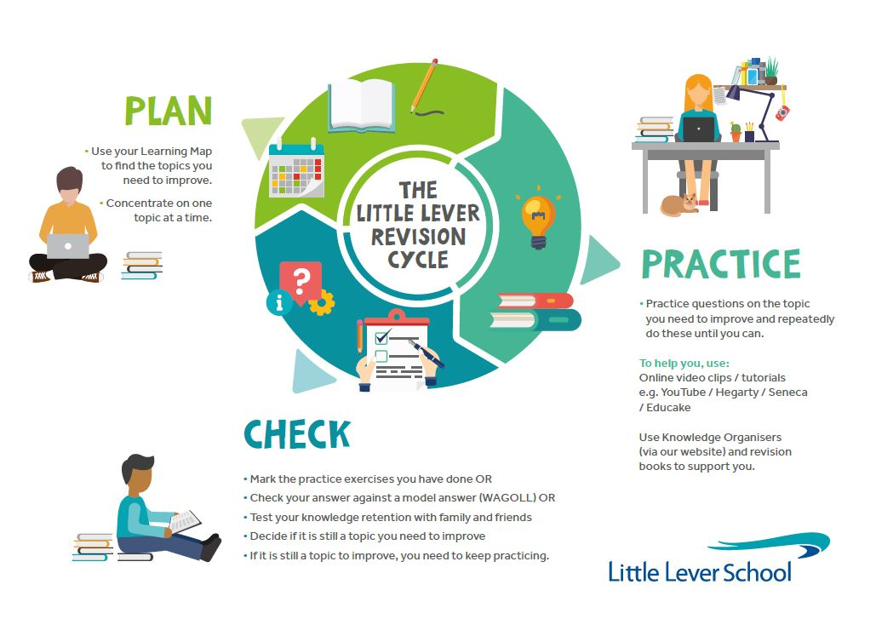

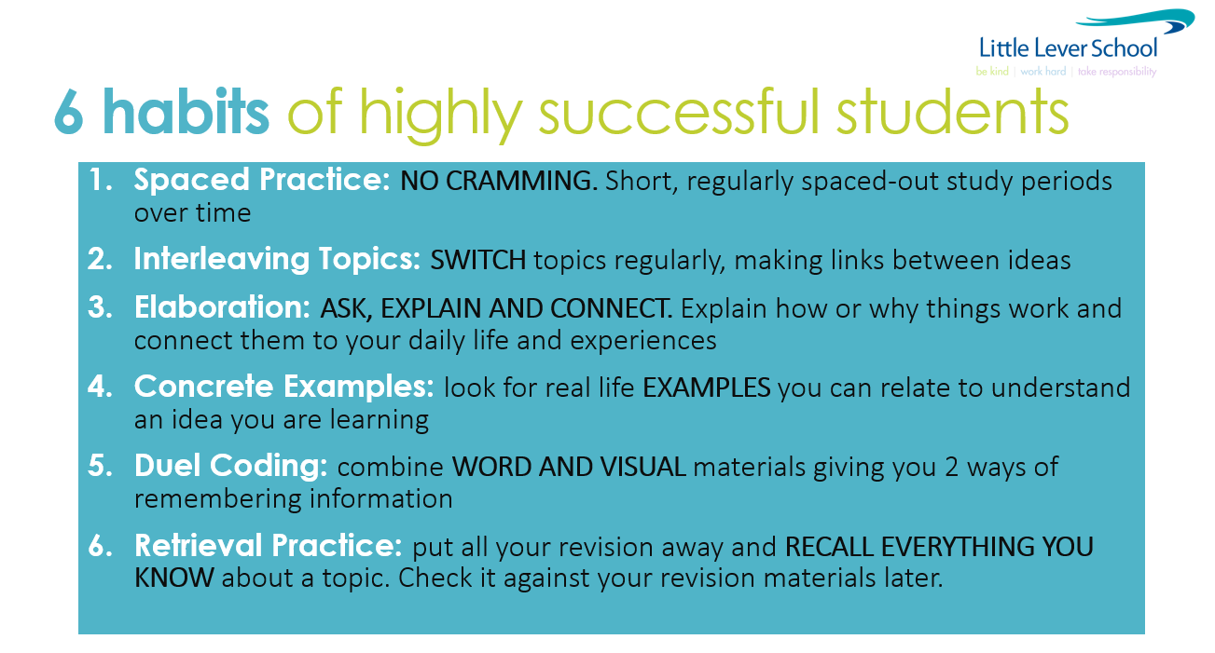 do I priori
Use these tips to help you revise and study effectively at home. There is a video guide which you can find at this YouTube page which goes into more detail about each of the 6 techniques.
https://www.youtube.com/watch?v=CPxSzxylRCI

Revision Timetable (All Exams/Assessments are in Yellow)

(Two 45min sessions EVERY night with a break in between. Write down the subject and topic you will focus each session on)

 |  | Revision session 1 (45mins) | Revision session 2 (45mins)
Example of what to plan |  | English Literature – The character of Duncan | Maths – Algebraic Equations – Hegarty
Monday | 13th June
Tuesday | 14th June
Wednesday | 15th June
Thursday | 16th June
Friday | 17th June
Saturday | 18th June
Sunday | 19th June
Monday | 20th June
Tuesday | 21st June
Wednesday | 22nd June
Thursday | 23rd  June
Friday | 24th June
Saturday | 25th June
Sunday | 26th June
Monday | 27th June | 9am Maths Paper 1 1h 30m  11.05am Combined Sci Biology Paper 1 - 1h 15m  11.05am Biology Paper 1 - 1h 45m  1.05pm Geography Combined Paper – in class  1.05pm Hospitality & Catering – in class  1.05pm Photography (SCO) – in class
Tuesday | 28th June | 9am Business Past Paper - in class  9am Geography Combined Paper – in class  9am Design Tech Past Paper – in class  9am Music Past Paper with new sections – in class  11.05am Combined Sci Chemistry Paper 1 - 1h 15m  11.05am Chemistry Paper 1 - 1h 45m  1.05pm English Language Paper 1 1h 45m
Wednesday | 29th June | 11.05am Combined Sci Physics Paper 1 - 1h 15m  Physics Paper 1 - 1h 45m
Thursday | 30th June | 9am Religious Studies Paper 1 1h 30m – in class  9am Geography Combined Paper – in class  9am Computer Science Paper 1 – in class  9am Design Technology Past Paper – in class  11.05am English Literature Paper 1 1h 45m  1.05pm Maths Paper 2 1h 30m
Friday | 1st July | School closed
Saturday | 2nd July
Sunday | 3rd July
Monday | 4th July | 9am Religious Studies Paper 1 1h 30m – in class  9am Hospitality & Catering Past Paper 1 – in class  9am Business Past Paper – in class  9am History Quiz & Essay – in class
Tuesday | 5th July | 11.05am Spanish Listening Paper – in class
Wednesday | 6th July | 11.05am Spanish Writing Paper – in class  11.05am History Quiz & Essay – in class
Thursday | 7th July
Friday | 8th July | 9am History Quiz & Essay – in class
Saturday | 9th July
Sunday | 10th July
Monday | 11th July
Tuesday | 12th July | 11.05am Sports Studies Practical Controlled Assessment
Wednesday | 13th July | 11.05am Sports Studies Practical Controlled Assessment
Thursday | 14th July | 11.05am Sports Studies Practical Controlled Assessment
Friday | 15th July | 9am Sports Studies Practical Controlled Assessment
Saturday | 16th July
Sunday | 17th July
Monday | 18th July
Tuesday | 19th July | All day Spanish Speaking Exams – individual appointments  1.15pm Sports Studies Practical Controlled Assessment
Wednesday | 20th July | 9am Sports Studies Practical Controlled Assessment

