Name:


Year 11 Revision Planner
Get Ready for Year 11 Mock Exams 1

e class: 3S2U88

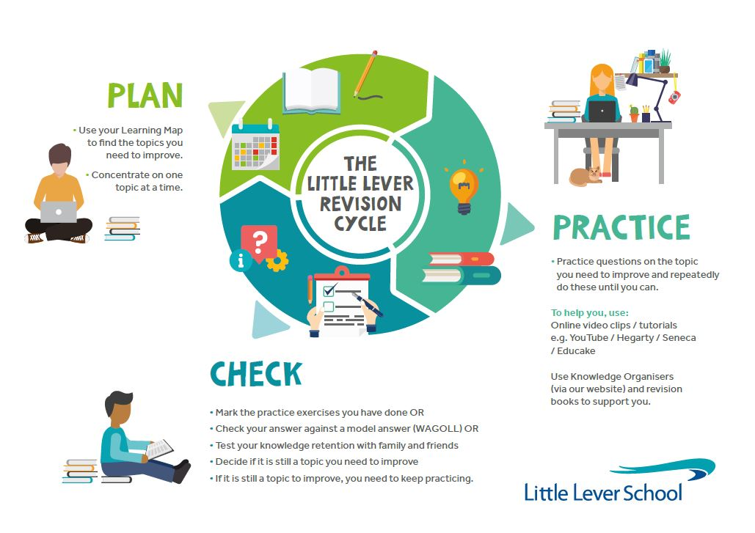
do I prioritise my child’s revision?

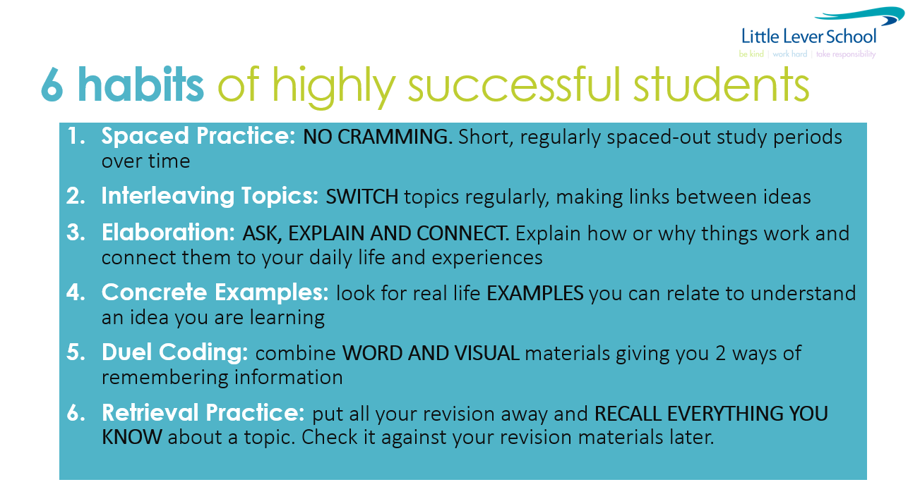
You make this happen. We will help you, but the success will be yours. We all want you to do well and everyone wants to help and encourage you!

GO FOR IT!

Revision Timetable – from now to your first mock exam

(Two 45min sessions EVERY night. Write down the subject and topic you will focus each session on)

Revision Times |  | 1st 45-minute Revision Session |  | 2nd 45-minute Revision Session
Example |  | English Literature  The character arc of Macbeth |  | Science  12+ mark question on Biology Paper 2
Monday | 9 Oct
Tuesday | 10 Oct
Wednesday | 11 Oct
Thursday | 12 Oct
Friday | 13 Oct
Saturday | 14 Oct
Sunday | 15 Oct
Monday | 16 Oct
Tuesday | 17 Oct | AM: English Literature / Paper 1 / 1h 45m
Wednesday | 18 Oct | PM: Combined Science / Biology Paper 1 / 1h 15m  Separate Science / Biology Paper 1 / 1h 45m
Thursday | 19 Oct
Friday | 20 Oct
Saturday | 21 Oct
Sunday | 22 Oct
Monday | 23 Oct | AM: Combined Science / Chemistry Paper 1 / 1h 15m  AM: Separate Science / Chemistry Paper 1 / 1h 45m |  | PM: Business / Paper 1 /1h 45m  PM: Computer Science / Paper 1 / 1h 40m
Tuesday | 24 Oct | AM: Maths / Paper 1 / 1h 30m |  | PM: Hospitality & Catering / Full Paper / 1h 30m  PM: DIT / Paper 1 / 1h 30m
Wednesday | 25 Oct |  |  | PM: Combined Science / Physics Paper 1 / 1h 15m
Thursday | 26 Oct | AM: Separate Science / Physics Paper 1 / 1h 45m  AM: Computer Science / Paper 1 / 1h 40m
Friday | 27 Oct | AM: Maths / Paper 2 / 1h 30m | AM: Hospitality & Catering / Full Paper / 1h 30m  AM: Business / Paper 1 /1 45m
Saturday | 28 Oct
Sunday | 29 Oct
Monday | 30 Oct
Tuesday | 31 Oct
Wednesday | 1 Nov
Thursday | 2 Nov
Friday | 3 Nov
Saturday | 4 Nov
Sunday | 5 Nov
Monday | 6 Nov
Tuesday | 7 Nov
Wednesday | 8 Nov
Thursday | 9 Nov
Friday | 10 Nov
Saturday | 11 Nov
Sunday | 12 Nov
Monday | 13 Nov | AM: English Language / Paper 1 / 1h 45m
Tuesday | 14 Nov | AM: Maths / Paper 3 / 1h 30m
Wednesday | 15 Nov
Thursday | 16 Nov | AM: Option A Computer Science / Paper 2 online / 2h
Friday | 17 Nov |  |  | PM: Option C Computer Science / Paper 2 online / 2h

