Name:

Year 11 Revision Planner
Get Ready for Year 11 Mock Exams 2

e class: 3S2U88

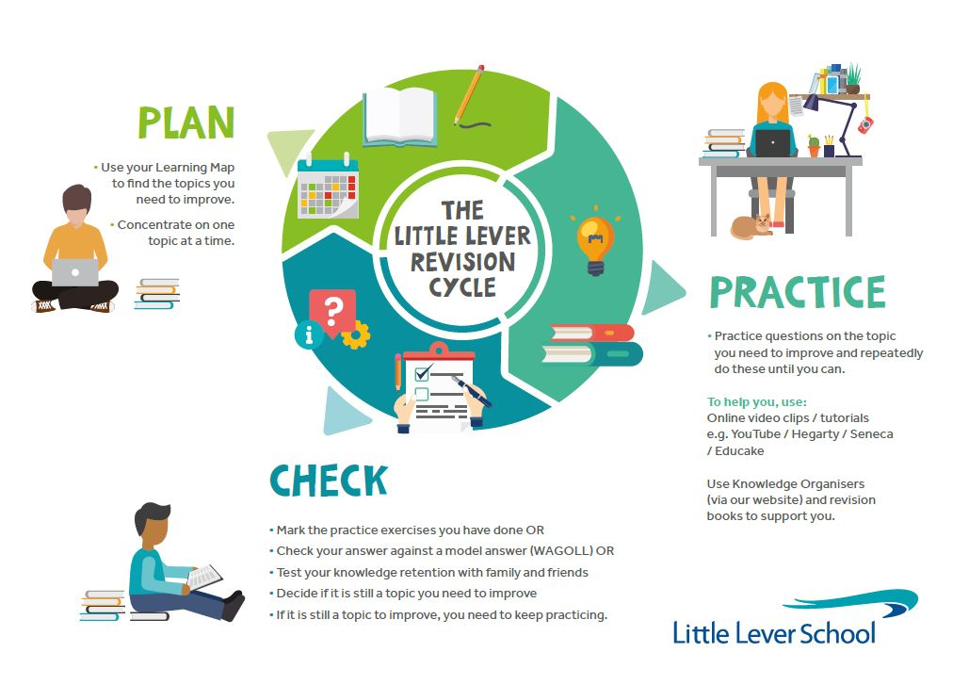
do I prioritise my child’s revision?

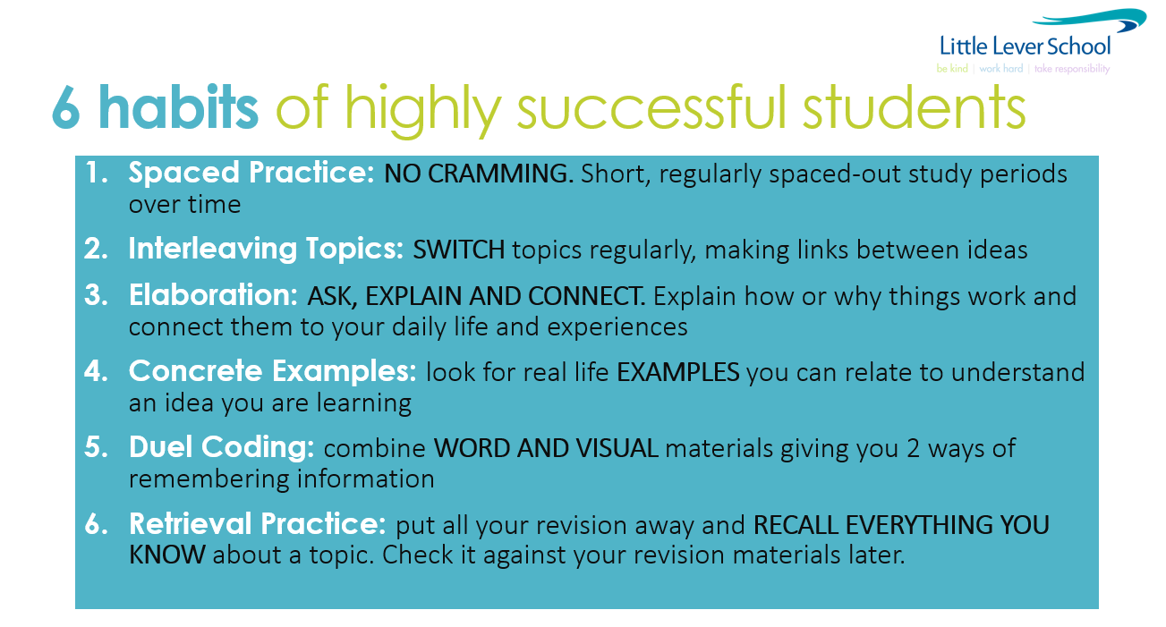
YOU make this happen. We will help you, but the success will be yours. We all want you to do well and everyone wants to help and encourage you!

GO FOR IT!

Revision Timetable – from now to your first mock exam

(Two 45min sessions EVERY night. Write down the subject and topic which need to improve in .

Revision Times |  | 1st 45-minute Revision Session |  | 2nd 45-minute Revision Session
Example |  | English Literature  The character arc of Macbeth |  | Science  12+ mark question on Biology Paper 2
Monday | 15 Jan
Tuesday | 16 Jan
Wednesday | 17 Jan
Thursday | 18 Jan
Friday | 19 Jan
Saturday | 20 Jan
Sunday | 21 Jan
Monday | 22 Jan
Tuesday | 23 Jan
Wednesday | 24 Jan
Thursday | 25 Jan
Friday | 26 Jan
Saturday | 27 Jan
Sunday | 28 Jan
Monday | 29 Jan
Tuesday | 30 Jan
Wednesday | 31 Jan
Thursday | 1 Feb
Friday | 2 Feb
Saturday | 3 Feb
Sunday | 4 Feb
Monday | 5 Feb |  |  | 1pm Option C Spanish / Paper 1 Listening F / 35m  1pm Option C Spanish / Paper 1 Listening H / 45m
Tuesday | 6 Feb |  |  | 1pm Option B History / Paper 1 / 2h  1pm Option B Geography / Paper 1 / 1h 30m
Wednesday | 7 Feb
Thursday | 8 Feb | 8.45am Option A Separate Science / Chemistry Paper 1 / 1h 45m  9am Option A Geography / Paper 1 / 1h 30m  11am Combined Science / Chemistry Paper 1 / 1h 30m
Friday | 9 Feb | 9am Maths / Paper 1 / 1h 30m  11am Option B Business / Paper 1 / 1h 45m  11am Option B French / Paper 1 (Listening) Foundation / 35m  11am Option B French / Paper 1 (Listening) Higher / 45m |  | 1pm Option B Business / Paper 1 / 1h 45m  1pm Option B Spanish / Paper 3 (Reading) Foundation / 45m  1pm Option B Spanish / Paper 3 (Reading) Higher / 1h  1pm Option B Geography / Paper 1 / 1h 30m
Saturday | 10 Feb
Sunday | 11 Feb
Monday | 12 Feb | 8.45am Separate Science / Biology Paper 1 / 1h 45m  9am Combined Science / Chemistry Paper 1 / 1h 30m |  | 1pm Option C History / Paper 1 / 2h  1pm Option C Computer Science / Paper 1 / 1h 40m  1pm Option C Business / Paper 2 / 1h 45m  1pm Option C Geography / Paper 1 / 1h 30m  1pm Option C Design Technology / Paper 1 / 1h 30m
Tuesday | 13 Feb | 8.45am English Literature / Paper 1 / 1h 45m |  | 1pm Option A History / Paper 1 / 2 hours  1pm Option A DIT / Paper 1 / 1h 30m  1pm Option A Geography / Paper 2 / 1h 30m  1pm Option A Computer Science / Paper 2 online / 2h
Wednesday | 14 Feb | 9am Maths / Paper 2 / 1h 30m |  | 1pm Combined Science / Physics Paper 1 / 1h 15m  1pm Separate Science / Physics Paper 1 / 1h 45m
Thursday | 15 Feb | 8.45am Computer Science / Paper 1 / 1h 40m  8.45am RE / Paper 1/ 1h 45mins
Friday | 16 Feb | 8.45am English Literature / Paper 2 / 2h 15m  11am Option B Design 11am Option B Technology / Paper 1 / 1h 30m  11am Option B Business / Paper 2 / 1h 45m  11am Option B Geography / Paper 2 / 1h 30m
Saturday | 17 Feb
Sunday | 18 Feb
Monday | 19 Feb
Tuesday | 20 Feb
Wednesday | 21 Feb
Thursday | 22 Feb
Friday | 23 Feb
Saturday | 24 Feb
Sunday | 25 Feb
Monday | 26 Feb | 9am Maths / Paper 3 / 1h 30m |  | 1pm Option C History / Paper 2 / 2h  1pm Option C Spanish / Paper 4 (Writing) / Foundation / 1h  1pm Option C Spanish / Paper 4 (Writing) / Higher / 1h 15m  1pm Option C Drama / Paper 1 / 1h 45
Tuesday | 27 Feb | 9am Combined Science / Biology Paper 2 / 1h 15m  8.45am Separate Science / Biology Paper 2 / 1h 45m |  | 1pm Option B History / Paper 2 / 2h  1pm Option B French / Paper 3 (Reading) Foundation / 45m  1pm Option B French / Paper 3 (Reading) Higher / 1h
Wednesday | 28 Feb | 8.45am English Language / Paper 1 / 1h 45m
Thursday | 29 Feb | 8.45am Option A History / Paper 2 / 2h  8.45am Option A RE / Paper 2 / 1h 45mins |  | 1pm Combined Science / Chemistry Paper 2 / 1h 1  1pm Separate Science / Chemistry Paper 2 / 1h 45m
Friday | 1 Mar | 8.45am English Language / Paper 2 / 1h 45m  11am Option B French / Paper 4 (Writing) / Foundation / 1h  11am Option B French / Paper 4 (Writing) / Higher / 1h 15m |  | 1pm Option C Computer Science / Paper 2 online / 2h
Saturday | 2 Mar
Sunday | 3 Mar
Monday | 4 Mar | 9am Combined Science / Physics Paper 2 / 1h 15m  8.45am Separate Science / Physics Paper 2 / 1h 45m
Tuesday | 5 Mar |  |  | 1pm Option A Music / Listening Paper / 1h 30m

