Name:

Year 11 Revision Planner
Get Ready for Summer GCSE Exams 2024

e class: 3S2U88

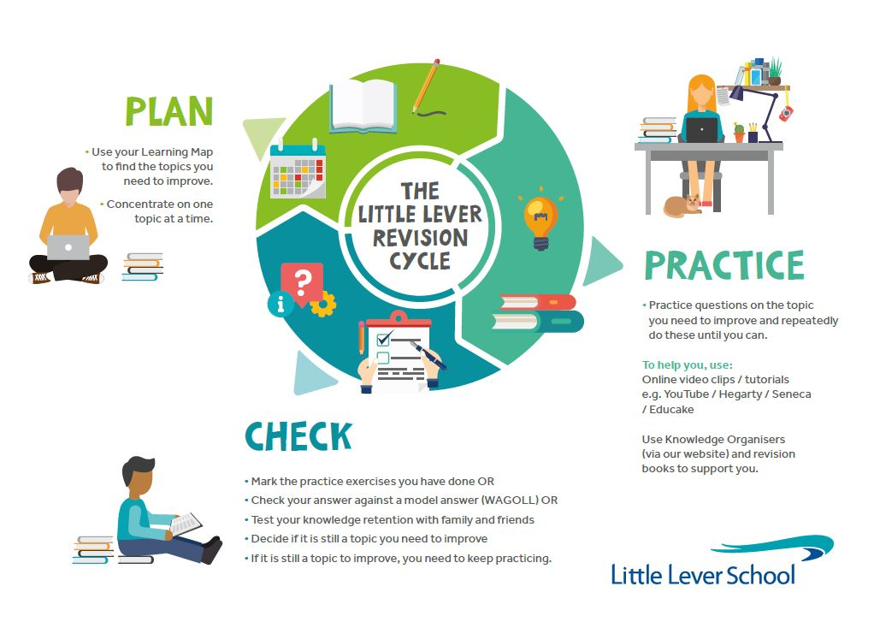
do I prioritise my child’s revision?

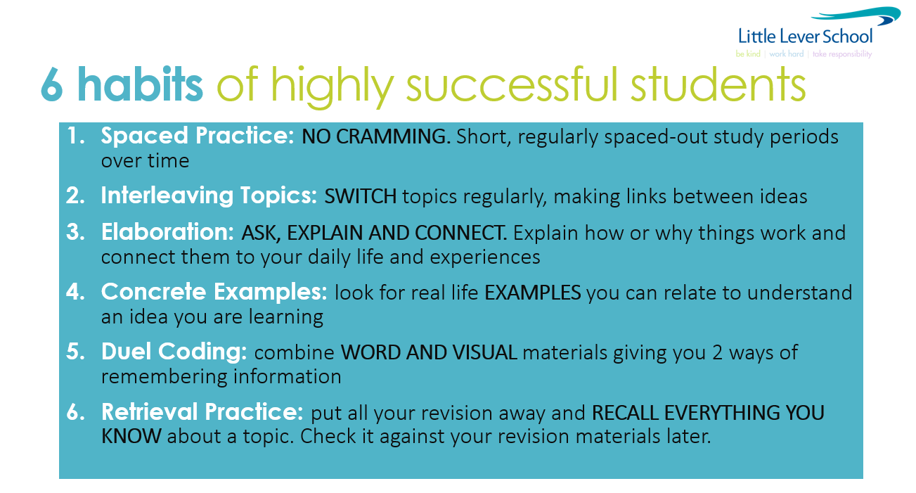
YOU make this happen. We will help you, but the success will be yours. We all want you to do well and everyone wants to help and encourage you!

GO FOR IT!

Revision Timetable – from now to your first mock exam

(Two 45min sessions EVERY night. Write down the subject and topic which need to improve in .

Revision Times |  | 1st 45-minute Revision Session |  | 2nd 45-minute Revision Session
Example |  | English Literature  The character arc of Macbeth |  | Science  12+ mark question on Biology Paper 2
Monday | 25 Mar
Tuesday | 26 Mar
Wednesday | 27 Mar
Thursday | 28 Mar
Friday | 29 Mar
Saturday | 30 Mar
Sunday | 31 Mar
Monday | 1 Apr
Tuesday | 2 Apr
Wednesday | 3 Apr
Thursday | 4 Apr
Friday | 5 Apr
Saturday | 6 Apr
Sunday | 7 Apr
Monday | 8 Apr
Tuesday | 9 Apr
Wednesday | 10 Apr
Thursday | 11 Apr
Friday | 12 Apr
Saturday | 13 Apr
Sunday | 14 Apr
Monday | 15 Apr
Tuesday | 16 Apr
Wednesday | 17 Apr
Thursday | 18 Apr
Friday | 19 Apr
Saturday | 20 Apr
Sunday | 21 Apr
Monday | 22 Apr
Tuesday | 23 Apr
Wednesday | 24 Apr
Thursday | 25 Apr
Friday | 26 Apr
Saturday | 27 Apr
Sunday | 28 Apr
Monday | 29 Apr
Tuesday | 30 Apr
Wednesday | 1 May
Thursday | 2 May | 8.45am DIT / Paper 1 / 1h 30m
Friday | 3 May
Saturday | 4 May
Sunday | 5 May
Monday | 6 May
Tuesday | 7 May
Wednesday | 8 May
Thursday | 9 May | 8.45am RE / Paper 1 / 1h 45m |  | 1pm Drama / Component 1 / 1h 45m
Friday | 10 May | 8.45am Biology / Paper 1 / 1h 45m  8.45am Combined Science / Biology Paper 1 / 1h 15m
Saturday | 11 May
Sunday | 12 May
Monday | 13 May | 8.45am English Literature / Paper 1 / 1h 45m
Tuesday | 14 May | 8.45am French / Listening F / 35m & Reading F / 45m  8.45am French / Listening H / 45m & Reading H / 1h |  | 1pm Business / Paper 1 / 1h 45m
Wednesday | 15 May | 8.45am History / Paper 1 / 2h |  | 1pm Computer Science / Paper 1 / 1h 30m
Thursday | 16 May | 8.45am Maths / Paper 1 / 1h 30m |  | 1pm RE / Paper 2 / 1h 45m
Friday | 17 May | 8.45am Chemistry / Paper 1 / 1h 45m  8.45am Combined Science / Chemistry Paper 1 / 1h 15m |  | 1pm Geography / Paper 1 / 1h 30m
Saturday | 18 May
Sunday | 19 May
Monday | 20 May | 8.45am English Literature / Paper 2 / 2h 15m
Tuesday | 21 May |  |  | 1pm Computer Science / Paper 2 / 2h
Wednesday | 22 May | 8.45am Physics / Paper 1 / 1h 45m  8.45am Combined Science / Physics Paper 1 / 1h 15m
Thursday | 23 May | 8.45am English Language / Paper 1 / 1h 45m
Friday | 24 May | 8.45am French / Writing F / 1h  French / Writing H / 1h 15m
Saturday | 25 May
Sunday | 26 May
Monday | 27 May
Tuesday | 28 May
Wednesday | 29 May
Thursday | 30 May
Friday | 31 May
Saturday | 1 Jun
Sunday | 2 Jun
Monday | 3 Jun | 8.45am Maths / Paper 3 / 1h 30m
Tuesday | 4 Jun | 8.45am  Spanish / Listening H / 45h  Spanish / Listening F / 35m  Spanish / Reading H / 1h  Spanish / Reading F / 45m |  | 1pm History / Paper 2 / 2h
Wednesday | 5 Jun | 8.45am Geography / Paper 2 / 1h 30m |  | 1pm Business / Paper 2 / 1h 45m
Thursday | 6 Jun | English Language / Paper 2 / 1h 45m
Friday | 7 Jun |  |  | 1pm Biology / Paper 2 / 1h 45m  1pm Combined Science / Biology Paper 2 / 1h 15m
Saturday | 8 Jun
Sunday | 9 Jun
Monday | 10 Jun | 8.45am Maths / Paper 3 / 1h 30m |  | 1pm Spanish / Writing H / 1h 15m  1pm Spanish / Writing F / 1h
Tuesday | 11 Jun | 8.45am Chemistry / Paper 2 / 1h 45m  8.45am Combined Science / Chemistry Paper 2 / 1h 15m
Wednesday | 12 Jun
Thursday | 13 Jun
Friday | 14 Jun | 8.45am Geography / Paper 3 / 1h 30m |  | 1pm Physics / Paper 2 / 1h 45m  1pm Combined Science / Physics Paper 2 / 1h 15m
Saturday | 15 Jun
Sunday | 16 Jun
Monday | 17 Jun |  |  | 1pm Music / Component 3 / 1h 15m
Tuesday | 18 Jun |  |  | 1pm Design & Technology / Paper 1 / 2h
Wednesday | 19 Jun |  |  | 1pm Hospitality & Catering / Paper 1 / 1h 20m

