Table of Contents

Overview and Rationale 3

Part A: Curriculum Music 4

INTENT 4

IMPLEMENTATION 4

Curriculum Planning 4

Scheme of Work Google Sheet (Live working document) 5

Listening 5

Performing 6

Composing 6

Assessment and Record Keeping 7

Music Tracker 7

SEND 7

Equality of Participation and Access 7

Timetable and KS3 frequency 8

Health and Safety 8

Individual Teacher’s Planning and Reporting 8

Staff Development 8

Part B: Co-curricular music 9

Enrichment 9

Instrumental Lessons and Visiting Tutors 9

Community Links 9

Bolton Music Hub 10

Part C: Musical Experiences 11

Performance Opportunities 11

Part D: In The Future 11

IMPACT 11

Roles and Responsibilities 12

Timeframe 12

# 

# Overview and Rationale

This plan is for the information of all teachers and staff, visiting tutors, Bolton Music Hub, and other relevant members of the school community.

**Rationale:**

At Little Lever School, we believe that the music curriculum should provide pupils with the opportunities to engage with a range of musical styles, through listening and appraising, composing, and performing. We strive for them to become involved in movement and drama through music.

**“We Believe In Helping Children Achieve Things They Never Thought They Could.”**

This plan has been devised in response to the governments document.

**‘*The power of music to change lives’ - ‘A National Plan for Music’ – June 2022.***

This plan has been devised in order to:

* Benefit the teaching and learning of music in our school.
* Provide a coherent approach to the teaching of music across the department.
* Review the existing plan for music considering the new Model Music Curriculum
* Create a core curriculum for all aspects of music for all class levels.
* To support and develop extracurricular opportunities for our students.
* To give access to instrumental/vocal lessons

|  |  |
| --- | --- |
| Detail | Information |
| Academic year that this summary covers | 2024 - 2025 |
| Date this summary was published | 25th May 2024 |
| Date this summary will be reviewed | 18th July 2024 |
| Name of the school music lead | Mr R Poole |
| Name of school leadership team member with responsibility for music (if different) | Mr S Cordwell |
| Name of local music hub | Bolton Music Hub |

# Part A: Curriculum Music

# INTENT

**Vision:**

Our vision is to cultivate a vibrant and inclusive music department where students are inspired to explore their creativity, develop their talents, and communicate through the universal language of music. We aim to create an environment that nurtures artistic expression, fosters a deep appreciation for diverse musical traditions, and equips students with the skills to excel both academically and personally through the power of music.

**Aims:**

We endorse the aims of the Model Music Curriculum and NPME to:

* Timetable curriculum music of at least one hour each week of the school year for key stages 3.
* Access to lessons across a range of instruments, and voice.
* A school choir and/or vocal ensemble.
* A school ensemble/band/group.
* Space for rehearsals and individual practice.
* A termly school performance.
* Opportunity to enjoy live performance at least once a year e.g. Foden’s Band, Halle Orchestra
* Enable the child to develop his/her musical potential and to experience the excitement and satisfaction of being actively engaged in musical creativity.
* Nurture the child’s self-esteem and self-confidence through participation in musical performance.
* Foster higher-order thinking-skills and lifelong learning through the acquisition of musical knowledge, skills, concepts, and values
* Enhance the quality of the child’s life through aesthetic musical experience.
* Foster a sense of community by singing together and performing.
* Provide pupils with an opportunity to perform using their musical talents e.g. Concerts, Vocal Competition, Community Days, Assemblies.

# IMPLEMENTATION

## Curriculum Planning

**Model Music Curriculum/Sequencing**

All teachers are familiar with the sequencing of units and how they fit within the new content objectives of the model music curriculum.

Teachers are encouraged to teach music using alternative methodologies and resources that match their own musical abilities and strengths. We utilise outside workshops and classes during the year and it is the responsibility of the class teacher to work with the facilitator of these classes/workshops to adapt their individual plans to cover the INTENT and ensure all students in the class are supported.

To guarantee continuity, progression, and consistency from class to class, teachers refer to our INTENT google sheet. This sheet lists all sequenced lessons and all information necessary for staff to teach those lessons e.g. WALT, Gold Standard, where each lesson meets the MMC, worksheets and PowerPoints. Collaborative planning along with informal and formal meetings between class teachers will be utilised to assist in planning.

## [Intent (Live working google sheet](https://docs.google.com/spreadsheets/d/1kIFfsEDwVZ8TID413EPVDFi6LmmIag2PU9DkRpnvFlk/edit" \l "gid=386072642)

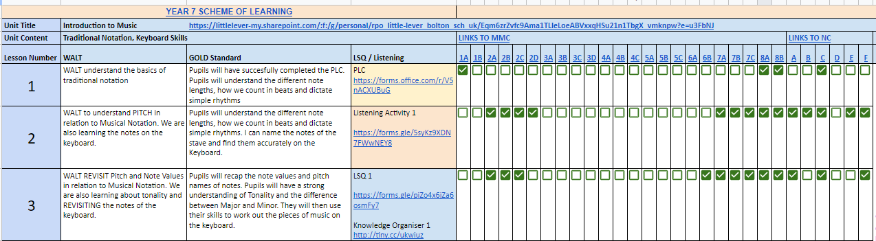

Teachers are familiar with the interrelated dimensions of music - a sense of pulse, duration, tempo, pitch, dynamics, structure, timbre, texture, style - to be taught.

All three strands – **Listening**, **Performing** and **Composing**, should be comprehensively covered but emphasis will be given to performing and given the current climate of Music, a strong focus on Music Technology.

All children at KS3 are actively engaged in music education in Little Lever School

Pupils are given the opportunity to engage with instrumental and vocal lessons with a member of staff, where they learn to read music and develop skills on their chosen instrument.

Opportunities are provided to enhance children’s lives through music by performing in our three concerts (one per term), Vocal competition, BandLab competition, School Shows and other school events.

## Listening

Children are provided with opportunities to listen and respond to music during their lessons. Every other lesson focusses on a Listening and Appraising Connect Now Activity. These pieces are taken from the Model Music Curriculum repertoire list to cover as large amount of music as possible. Teachers ensure that pupils experience a wide range of musical styles, traditions, and cultures as evident in the selection of pieces for the core curriculum.

The teacher provides opportunities for active listening and responding e.g. through questioning, prompting, suggesting, listening to short examples repeatedly and responding in some of the following ways:

* Talking about …
* Listening for specific instruments and/or specific features
* Following/creating a pictorial score of music
* Writing in response to music or Composing
* Singing or playing along with music
* Musical games and/or action songs

Children are provided with opportunities to work in different groupings, e.g. whole group, small groups, pairs, individually.

Children are provided with opportunities to work collaboratively/co-operatively.

Children are provided with opportunities to offer varying and creative solutions to presented problems.

A broad range of materials is provided for listening and responding e.g.

* Recorded music on video, CD, or music technology.
* Tuned and untuned percussion instruments.
* Melodic instruments such as piano, ukulele, guitar
* Performance of a group, ensemble, band, choir, orchestra visiting the school or at another venue.
* Recorded music is selected from a wide range of sources, all listed on the Model Music Curriculum e.g. classic folk, traditional Irish, music from other countries, choral and instrumental and music for different occasions.

## Performing

In the Performing strand all the following are emphasised

* Active enjoyable participation
* Development of skills, understanding, knowledge
* Fostering of children’s attitude and interests
* Development of creativity.

Approaches to music literacy include pictorial representation of rhythm, graphic scores stick notation and traditional notation.

Children are provided with opportunities to play a variety of instruments at appropriate times in class. These sessions are structured so that students have a key focus of embedding skills not just playing.

## Composing

Children are encouraged to compose music as part of the Composing strand through.

* Composing simple chord structures on piano
* Composing melodies to a given chord sequence
* Composing for a purpose (programme music)
* Composing pieces that are written down in graphic score and traditional notation.
* Composing by using a variety of different technologies e.g. BandLab, GarageBand, Sibelius, Noteflight.

We recognise that there is a natural linkage across the strands of the music curriculum e.g. while pupils are engaged in a Performing and Composing lesson, they will also be Listening and Responding.

## Assessment and Record Keeping

Assessment plays a crucial role in the teaching and learning of music by identifying the skills pupils already possess and highlighting areas that need revisiting, mastery, or advancement. It evaluates children's overall musical ability, interest, and participation levels, as well as individual aspects of each musical strand.

Teacher observation and verbal feedback serve as the primary assessment tools, ensuring a comprehensive and dynamic approach to student development in music.

Other assessment tools used are.

* Teacher-designed tasks
* Recordings of the children’s work (often submitted online via bandlab/garageband)
* Graphic/pictorial scores.
* Performance at a particular school event e.g. Christmas Concert

Assessment is recorded in teachers’ notes and in the end of year report designed by RPO.

This is communicated to parents in the end-of-term report as an export of the tracking document.

## 

## Music Tracker

All students will complete a PLC (Personalised Learning Checklist) once a term to check their knowledge of key elements of music and strands of the curriculum e.g. Instruments of the orchestra, musical styles etc. Every other Music lesson starts with a Low Stakes Quiz or a Listening Activity. These are again recorded and displayed on the pupil’s tracker to monitor progress throughout the unit. Finally, pupil practical progress is measured over a series of lessons, not a final assessment. This is a holistic view of their skills rather than a summative judgement on one 30 second performance. Constant effective, timely and accurate verbal feedback is key to the development of pupils in Music.

## 

## SEND

At Little Lever School, all pupils participate in music within the classroom. Teachers will, if required, vary the pace, content, and methodologies to ensure learning and success for all pupils. Every effort will be made to simplify the language and technology for pupils with SEND. Equally, where a teacher recognises a musical talent within a pupil, this will be nurtured as far as possible, and the teacher will communicate this with the parents/guardians so that they may nurture the talent e.g. after school class in Extra Curricular groups.

## 

## Equality of Participation and Access

Equal opportunities are given to all pupils regardless of gender, ethnic background or socioeconomic status across all strands and activities. Music class may be used as a means of integrating different cultural backgrounds, which may exist in the class at the time.

## Timetable and KS3 frequency

Time is allocated on a two-week timetable with classes at KS3 receiving a 100-minute lesson once a fortnight. This is something we value highly in the department. 100-minute lessons give fantastic opportunity to not only embed the foundations of the lesson, but also give adequate time for students to work on key knowledge, concepts, and mastering skills.

## Health and Safety

Teachers are constantly aware of health and safety when conducting lessons. When planning, and during Music lessons, consideration will be given to the following:

* Hidden dangers when pupils are moving around the classroom.
* Storage facilities
* Access to, and transport of, equipment and instruments
* Ventilation of the classrooms
* Amount of space for pupils to sit/stand when doing choral or instrumental work.
* Appropriate volume levels when using audio equipment and instruments.

## Individual Teacher’s Planning and Reporting

This whole school plan, core curriculum and the curriculum documents for music, provide information and guidance to individual teachers for both their long- and short-term planning.

These will be reviewed in collaboration with the department during weekly collaborative planning sessions.

## Staff Development

* Teachers have access to reference books, resource materials, instruments, equipment, and websites dealing with music.
* Staff are consulted about the purchasing of instruments and materials for music.
* Information about in-service courses, school visits, musical events are communicated to all by RPO.
* We are always looking at opportunities for staff with expertise in the areas of music to share their ideas with other staff members e.g. co-operative teaching.
* Time is allocated at staff meetings (collaborative planning) to discuss aspects of the music curriculum.
* Links have been made with Bolton Hub for bespoke CPD sessions.
* Head of Faculty attends network meetings when available.

# 

# Part B: Co-curricular music

## Enrichment

The Music department has a rich history of running extracurricular clubs, this is on the rise once more following the setback which was Covid-19. Below is the current timetable of events which will be developed further into 2024-25.

|  |  |  |  |  |
| --- | --- | --- | --- | --- |
| **Monday** | **Tuesday** | **Wednesday** | **Thursday** | **Friday** |
| **AM Prep –**  Drum Group  **After School** – Rock Band Practice / School Production | **AM Prep –**  Advanced Guitars  **After School** – Rock Band Practice / School Production | **AM Prep –**  Advanced Guitars / Advanced Wind Group  **After School** – Rock Band Practice | **AM Prep –**  All Inclusive Jazz Band  **Enrichment** – Beginner Guitars  **After School** – Rock Band Practice | **AM Prep –**  All Inclusive Jazz Band |

## Instrumental Lessons and Visiting Tutors

We have several tutors visiting the school to teach a wide range of instruments. RPO teaches beginner piano and brass, MCO teaches guitar. These lessons are taught during timetabled free periods (surplus periods) on the timetable to give high quality provision on these instruments. The remaining instruments, Drums, Woodwind, Advance Piano and Vocal are provided by self-employed instrumental teachers or the local Bolton Music Hub. Below are the hours per week and funding costs as of 26/05/23.

## Community Links

The staff at Little Lever School are very open and encouraging to any member of the local community who wishes to share their musical talent/skill with the pupils and will facilitate this where possible. Community members are invited to attend school events. Performances in music are uploaded on the school website and YouTube channel, for parents/guardians and community members to view. The Christmas Concert every year includes the local Primary School Brass Band (St Matthews Primary School) and the World Famous Foden’s Band. This acts as an inspirational tool to both students at Little Lever School and St Matthew’s Primary School, as well as their parents and the local community.

## 

## Bolton Music Hub

We have strong links with the Bolton Music Hub and a number of young Musicians from Little Lever School attend the evening ensembles held at Mere Hall. These are open to all students and a timetable can be found below of when the different activities take place.

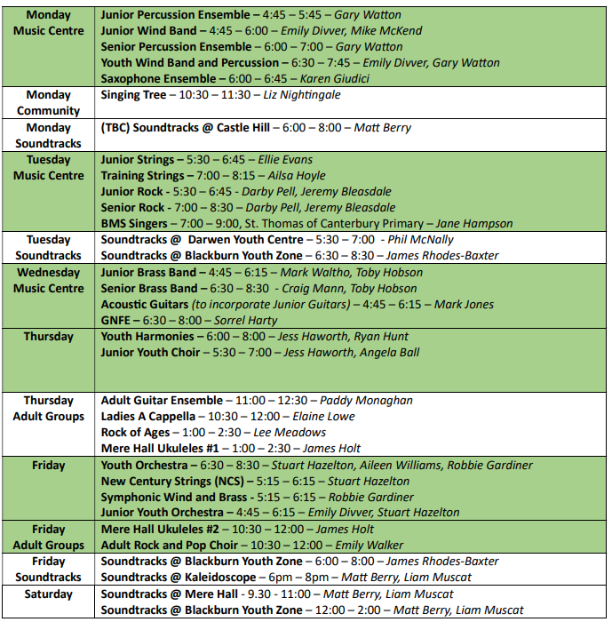

# Part C: Musical Experiences

## Performance Opportunities

There are three main performance opportunities throughout the school year.

**Winter Concert** – All school ensembles perform in the first half of the concert with selected soloists. The end of the first half is performed by the local primary school brass band from St Matthews Primary School. The second half of the concert is the Foden’s Brass Band, during which a selection of students from our school are soloists with this world class band.

**Spring Concert** – All school ensembles perform and anyone who wants to perform a solo may perform also. This is a free concert for parents and carers.

**Summer Concert** – As above with the spring concert

**Young Musician of the Year** – A competition for instrumentalists and an opportunity for GCSE students to perform their exam pieces. External judges to provide an unbiased adjudication.

**Halle Orchestra ‘Music for Youth’** – Students studying GCSE music and peripatetic lessons are given the opportunity to visit the Bridgewater Hall and the Halle for Youth concerts.

**RNCM Composition Workshops** – Lecturers and composition students from the RNCM visit Little Lever to give support and workshops for compositions.

# Part D: In The Future

The Music department has always had high expectations of all pupils and their musical goals. We aim to continue to inspire the pupils at Little Lever School and help them “Achieve Things They Never thought They Could”

Below is our key focus for the department for the future.

* Overhaul of the Apple Mac computers to further allow a deepening in knowledge and skills of the Music Tech industry.
* To increase participation in instrumental and vocal lessons.
* To have a choir as part of the enrichment opportunities
* To develop further singing opportunities within the curriculum.
* To develop links with local schools and put on collaborative events.
* Provide music students with residential weekends.

# IMPACT

The success of this whole school plan will be monitored and assessed; we will know if the plans have enhanced pupil learning if:

* Children have a positive attitude and appreciation of music.
* Children have an interest in expression through music.
* Children engage in listening and responding, performing, and composing music.
* Children have explored sound including vocal sound, body percussion, instruments, and environmental sounds.
* Children have listened and responded to music from a wide variety of genres and cultures in a variety of ways.
* Children sing songs appropriate to their vocal range from a wide variety of genres and cultures.
* Children play a variety of instruments.
* Children experience a variety of ways of recording music which may include graphic, pictorial, ICT, and traditional music notation.
* Children improvise and create music using a variety of sound sources.
* Children talk about, evaluate, and record their work.

## Roles and Responsibilities

The Faculty Lead, Mr Richard Poole, has responsibility for the development of music within the school.

**Faculty Leader of the Arts**: Richard Poole (Lead on GCSE Music and KS3 curriculum)

**Teacher of Music**: Matthew Cornish (Lead of Eduqas Performing Arts Award)

## Timeframe

This plan will be implemented immediately.

It will be necessary to review this plan on a regular basis to ensure optimum implementation of the music curriculum in the school.