**Name:**



**Year 10 Revision Planner**

Get Ready for Summer Exams

e class: 3S2U88

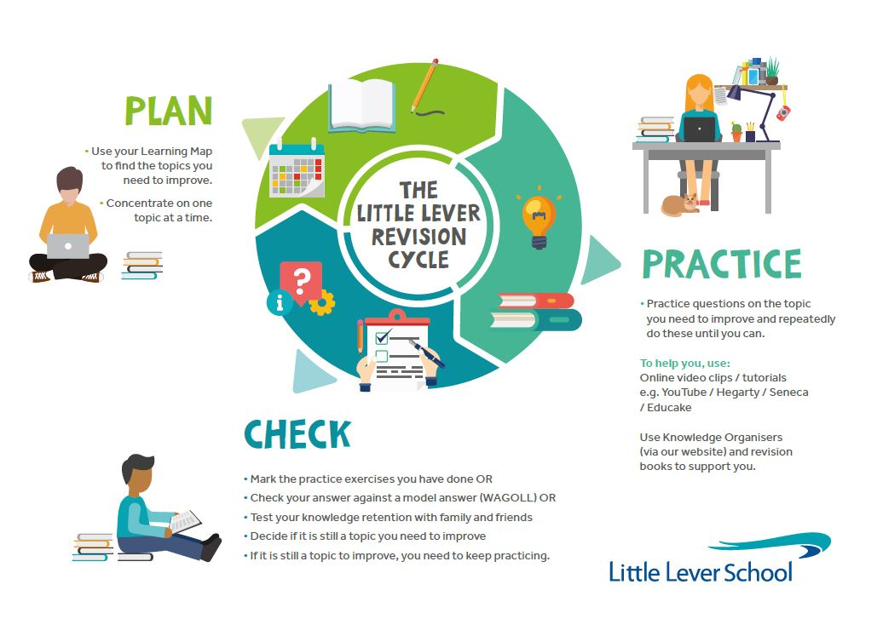

do I prioritise my child’s revision?

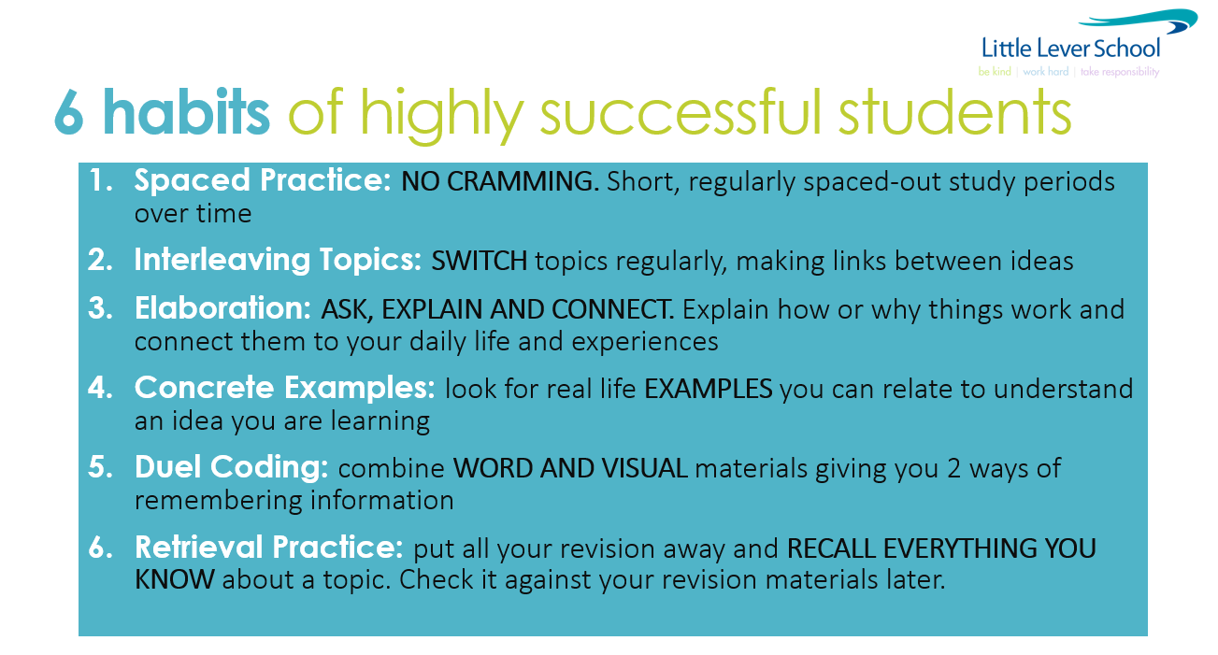**YOU make this happen. We will help you, but the success will be yours. We all want you to do well and everyone wants to help and encourage you!**

**GO FOR IT!**

Revision Timetable – from now to your first exam

(**Two 45min sessions EVERY night. Write down the subject and topic which need to improve in.**

**During weekends, decide which part of the day to complete your two 45-minute revision sessions – morning, afternoon or evening?**

|  |  |  |  |  |  |
| --- | --- | --- | --- | --- | --- |
| **Revision Times** | | **1st 45-minute Revision Session** | | **2nd 45-minute Revision Session** | |
| Example | | Maths – Finding equations of straight-line graphs | | English Language – Paper 2, Q2 | |
| Monday | 3 Jun |  | |  | |
| Tuesday | 4 Jun |  | |  | |
| Wednesday | 5 Jun |  | |  | |
| Thursday | 6 Jun |  | |  | |
| Friday | 7 Jun |  | |  | |
| Saturday | 8 Jun |  | |  | |
| Sunday | 9 Jun |  | |  | |
| Monday | 10 Jun |  | |  | |
| Tuesday | 11 Jun |  | |  | |
| Wednesday | 12 Jun |  | |  | |
| Thursday | 13 Jun |  | |  | |
| Friday | 14 Jun |  | |  | |
| Saturday | 15 Jun |  | |  | |
| Sunday | 16 Jun |  | |  | |
| Monday | 17 Jun |  | |  | |
| Tuesday | 18 Jun |  | |  | |
| Wednesday | 19 Jun |  | | 1pm Maths / Paper 1 / 1h 30m |  |
| Thursday | 20 Jun | Geography Field Trip |  |  | |
| Friday | 21 Jun | 9.10am  Spanish Op A & C / Reading F / 45m  Spanish Op A & C / Reading H / 1h  French Op A & C / Reading F / 45m  French Op A & C / Reading H / 1h |  | 1pm English Literature / Paper 1 / 1h 35m |  |
| Saturday | 22 Jun |  | |  | |
| Sunday | 23 Jun |  | |  | |
| Monday | 24 Jun | 9am Maths / Paper 2 / 1h 30m  11am Drama / 1h |  | 1pm  Combined Science / Biology / 1h 15m  Separate Science / Biology / 1h 45m |  |
| Tuesday | 25 Jun | 9am Geography / 1h 30m |  | 1pm History / 1h 45m |  |
| Wednesday | 26 Jun | 1pm  Combined Science / Chemistry / 1h 15m  Separate Science / Chemistry / 1h 45m |  |  | |
| Thursday | 27 Jun | 9am Maths / Paper 3 / 1h 30m |  | 1pm Drama / 1h 15m |  |
| Friday | 28 Jun | 9.10am  Spanish Op A & C / Writing F / 1h 5m  Spanish Op A & C / Writing H / 1h 20m  French Op A & C / Writing F / 1h 5m  French Op A & C / Writing H / 1h 20m  9.10am Music / 1h |  |  | |
| Saturday | 29 Jun |  | |  | |
| Sunday | 30 Jun |  | |  | |
| Monday | 1 Jul | 8.45am English Language / Paper 2 / 1h 45m |  | 1pm  Combined Science / Physics / 1h 15m  Separate Science / Physics / 1h 45m |  |