**Name:**



**Year 11 Revision Planner**

Get Ready for Summer GCSE Exams 2025

e class: 3S2U88

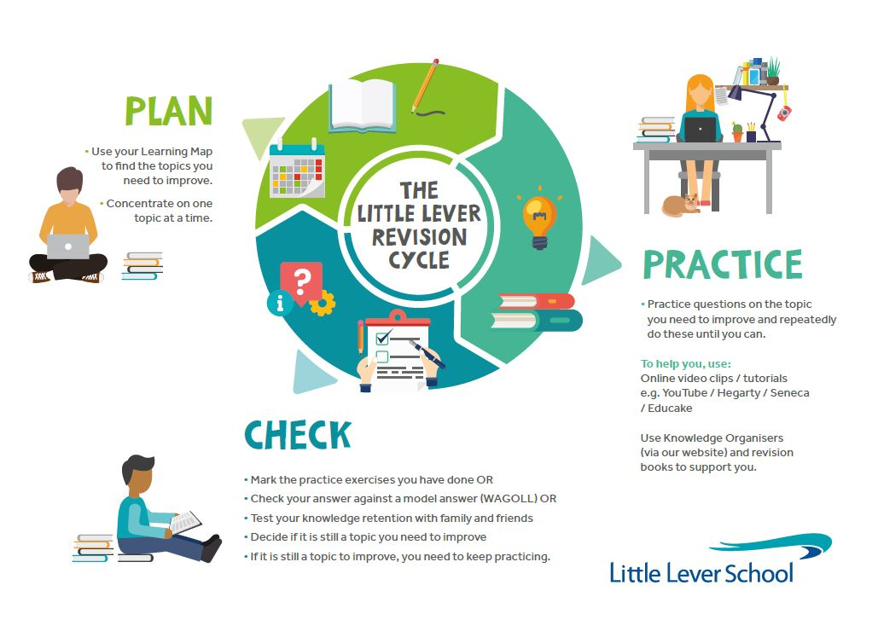

do I prioritise my child’s revision?

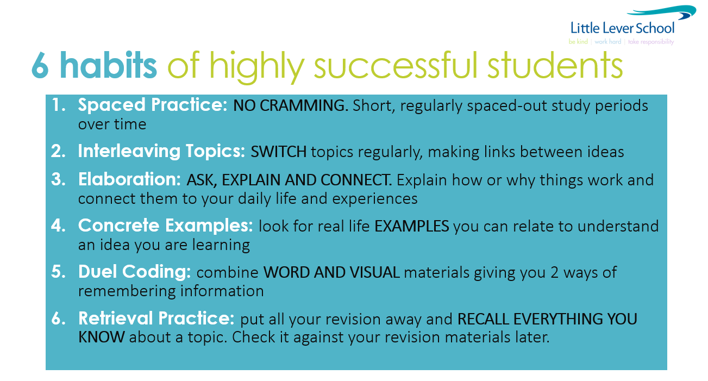**YOU make this happen. We will help you, but the success will be yours. We all want you to do well and everyone wants to help and encourage you!**

**GO FOR IT!**

Revision Timetable – from now to your first mock exam

(**Two 45min sessions EVERY night. Write down the subject and topic which need to improve in.**

**During weekends and the Easter and MAY Half Term holidays, decide which two of the three times of the day you will do your 45-minute revision session.**

|  |  |  |  |  |  |  |  |  |
| --- | --- | --- | --- | --- | --- | --- | --- | --- |
| **Revision Times** | | **1st 45-minute Revision Session** | | | | **2nd 45-minute Revision Session** | | |
| Example | | English Literature  The character arc of Macbeth | | | | Science  12+ mark question on Biology Paper 2 | | |
| Monday | 7 Apr | Maths – Finding equations of straight-line graphs | | | | English Language – Paper 2, Q2 | | |
| Tuesday | 8 Apr |  | | | |  | | |
| Wednesday | 9 Apr |  | | | |  | | |
| Thursday | 10 Apr |  | | | |  | | |
| Friday | 11 Apr |  | | | |  | | |
| Saturday | 12 Apr | Morning e.g. Science – Malaria and the cell cycle | | | Afternoon e.g. Science – Radioactivity and half life | | Evening | |
| Sunday | 13 Apr | Morning | | | Afternoon | | Evening | |
| Monday | 14 Apr | Morning | | | Afternoon | | Evening | |
| Tuesday | 15 Apr | Morning | | | Afternoon | | Evening | |
| Wednesday | 16 Apr | Morning | | | Afternoon | | Evening | |
| Thursday | 17 Apr | Morning | | | Afternoon | | Evening | |
| Friday | 18 Apr | Morning | | | Afternoon | | Evening | |
| Saturday | 19 Apr | Morning | | | Afternoon | | Evening | |
| Sunday | 20 Apr | Morning | | | Afternoon | | Evening | |
| Monday | 21 Apr | Morning | | | Afternoon | | Evening | |
| Tuesday | 22 Apr | Morning | | | Afternoon | | Evening | |
| Wednesday | 23 Apr |  | | | |  | | |
| Thursday | 24 Apr |  | | | |  | | |
| Friday | 25 Apr |  | | | |  | | |
| Saturday | 26 Apr | Morning | | | Afternoon | | Evening | |
| Sunday | 27 Apr | Morning | | | Afternoon | | Evening | |
| Monday | 28 Apr |  | | | |  | | |
| Tuesday | 29 Apr |  | | | |  | | |
| Wednesday | 30 Apr |  | | | |  | | |
| Thursday | 1 May |  | | | |  | | |
| Friday | 2 May |  | | | |  | | |
| Saturday | 3 May | Morning | | | Afternoon | | Evening | |
| Sunday | 4 May | Morning | | | Afternoon | | Evening | |
| Monday | 5 May |  | | | |  | | |
| Tuesday | 6 May |  | | | |  | | |
| Wednesday | 7 May |  | | | |  | | |
| Thursday | 8 May | 8.45am Drama / Component 1 / 1h 45m | |  | |  | | |
| Friday | 9 May |  | | | | 1pm Business / Paper 1 / 1h 45m | |  |
| Saturday | 10 May | Morning | | | Afternoon | | Evening | |
| Sunday | 11 May | Morning | | | Afternoon | | Evening | |
| Monday | 12 May | 8.45am English Literature / Paper 1 / 1h 45m | |  | | 1pm Computer Science / Paper 1 / 1h 30m | |  |
| Tuesday | 13 May | 8.45am RE / Paper 1 / 1h 45m | |  | | 1pm Biology / Paper 1 / 1h 45m  1pm Combined Science / Biology Paper 1 / 1h 15m | |  |
| Wednesday | 14 May | 8.45am Geography / Paper 1 / 1h 30m | |  | | 1pm Sports Studies / 1h 15m | |  |
| Thursday | 15 May | 8.45am Maths / Paper 1 / 1h 30m | |  | |  | | |
| Friday | 16 May | 8.45am History / Paper 1 / 2h | |  | | 1pm Business / Paper 2 / 1h 45m | |  |
| Saturday | 17 May | Morning | | | Afternoon | | Evening | |
| Sunday | 18 May | Morning | | | Afternoon | | Evening | |
| Monday | 19 May | 8.45am Chemistry / Paper 1 / 1h 45m  8.45am Combined Science / Chemistry Paper 1 / 1h 15m |  | | | Urdu / Listening H / 45m  Urdu / Reading H / 1h 05m | |  |
| Tuesday | 20 May | 8.45am English Literature / Paper 2 / 2h 15m |  | | | 1pm Computer Science / Paper 2 / 2h | |  |
| Wednesday | 21 May | 8.45am  French / Listening F / 35m & Reading F / 45m  French / Listening H / 45m & Reading H / 1h |  | | | 1pm RE / Paper 2 / 1h 45m | |  |
| Thursday | 22 May | 8.45am Physics / Paper 1 / 1h 45m  8.45am Combined Science / Physics Paper 1 / 1h 15m | |  | |  | | |
| Friday | 23 May | 8.45am English Language / Paper 1 / 1h 45m | |  | |  | | |
| Saturday | 24 May | Morning | | | Afternoon | | Evening | |
| Sunday | 25 May | Morning | | | Afternoon | | Evening | |
| Monday | 26 May | Morning | | | Afternoon | | Evening | |
| Tuesday | 27 May | Morning | | | Afternoon | | Evening | |
| Wednesday | 28 May | Morning | | | Afternoon | | Evening | |
| Thursday | 29 May | Morning | | | Afternoon | | Evening | |
| Friday | 30 May | Morning | | | Afternoon | | Evening | |
| Saturday | 31 May | Morning | | | Afternoon | | Evening | |
| Sunday | 1 Jun | Morning | | | Afternoon | | Evening | |
| Monday | 2 Jun | 8.45am Urdu / Writing Test Tier H / 1h 25m | |  | |  | | |
| Tuesday | 3 Jun |  | | | |  | | |
| Wednesday | 4 Jun | 8.45am Maths / Paper 2 / 1h 30m | |  | |  | | |
| Thursday | 5 Jun | 8.45am History / Paper 2 / 2h | |  | | 1pm French / Writing Test Tier F / 1h  1pm French / Writing Test Tier H / 1h 15m | |  |
| Friday | 6 Jun | 8.45am English Language / Paper 2 / 1h 45m | |  | | 1pm Geography / Paper 2 / 1h 30m | |  |
| Saturday | 7 Jun | Morning | | | Afternoon | | Evening | |
| Sunday | 8 Jun | Morning | | | Afternoon | | Evening | |
| Monday | 9 Jun | 1pm Biology / Paper 2 / 1h 45m  1pm Combined Science / Biology Paper 2 / 1h 15m |  | | | 1pm  Spanish / Listening H / 45h  Spanish / Listening F / 35m  Spanish / Reading H / 1h  Spanish / Reading F / 45m | |  |
| Tuesday | 10 Jun | 8.45am Maths / Paper 3 / 1h 30m |  | | | 1pm Geography / Paper 3 / 1h 30m | |  |
| Wednesday | 11 Jun | 8.45am  Greek / Listening Test Tier H / 45m  Greek / Reading Test Tier H / 1h 05m |  | | | 1pm Hospitality & Catering / Paper 1 / 1h 20m | |  |
| Thursday | 12 Jun | 8.45am Chemistry / Paper 2 / 1h 45m  8.45am Combined Science / Chemistry Paper 2 / 1h 15m |  | | |  | | |
| Friday | 13 Jun |  | | | |  | | |
| Saturday | 14 Jun | Morning | | | Afternoon | | Evening | |
| Sunday | 15 Jun | Morning | | | Afternoon | | Evening | |
| Monday | 16 Jun | 8.45am Physics / Paper 2 / 1h 45m  8.45am Combined Science / Physics Paper 2 / 1h 15m | |  | | 1pm Music / Component 3 / 1h 15m | |  |
| Tuesday | 17 Jun | 8.45am Spanish / Writing H / 1h 15m  8.45am Spanish / Writing F / 1h | |  | |  | | |
| Wednesday | 18 Jun | 8.45am Design & Technology / Paper 1 / 2h | |  | |  | | |
| Thursday | 19 Jun | English Language / Paper 2 / 1h 45m | |  | | Greek / Writing Test Tier H / 1h 25m | |  |