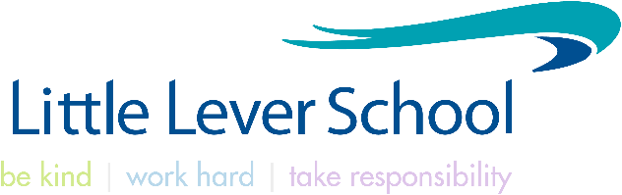

***‘Helping every person achieve things they never thought they could’***

**TEACHER OF SCIENCE**

**Teachers’ Pay Scale**

**Permanent**

**Starting September 2025**

Little Lever School was one of the most improved schools in the country and our outcomes remain in the top 100 schools nationally for similar schools. Our school was graded Good by OfSTED in March 2022 and has continued to move forward at pace. We are a Teach First partner school and support schools from across the North West in a range of areas. The systems and structures we have established, our clear expectations and relentless focus on our praise culture, routines and behaviour have created a positive environment where students can learn, and teachers can teach.

This is an exciting time to join Little Lever as we look to expand, providing the best educational experiences for more pupils. Our ambition is to become ‘the best in class’. We put students at the heart of our thinking and we continue to help every person achieve things they never thought they could!

***Please visit our website to gather a flavour of what we are all about!***

This is an exciting opportunity for an inspirational, talented and driven Teacher of Science to join our enthusiastic team as we aim to create a ‘world class’ school.

The school is committed to safer recruitment practice and pre-employment checks will be undertaken before any appointment is confirmed. This post is subject to an enhanced disclosure from the Disclosure and Barring Service (DBS). The school is committed to safeguarding and promoting the welfare of children and young people and it expects staff and volunteers to share this commitment.

Completed applications should be returned to the Principal, Mr D Mckeon via HR [recruitment@little-lever.bolton.sch.uk](mailto:recruitment@little-lever.bolton.sch.uk)

**Closing date for applications & shortlisting: 9am Friday 25th April 2025**

**\*Previous applicants need not apply**